Successfully completed the TASK given by Mr. Vimal Daga Sir in EKS Training at LinuxWorld Information Pvt Ltd.

The objective of the task was to:

1. Create Kubernetes Cluster using AWS EKS.

2. Integrate of EKS with Services like Ec2, EBS, EFS, LB.

3. Create a Multi-tier Architecture of Wordpress & MySQL on the top of EKS

4. Using Helm to install Prometheus and Grafana

5. Create a Server less Architecture by Fargate Cluster

EKS(Elastic Kubernetes Services)

Amazon EKS is a managed service that makes it easy for you to run Kubernetes on the AWS without need to stand up or maintain your own Kubernetes control plan. Kubernetes is an open-source system for automating the deployment, scaling and management of containerized applications.

Amazon EKS runs Kubernetes control plane instances across multiple Availability Zones to ensure high availability. Amazon EKS detects and replaces unhealthy control practice instances, and it provides automated version upgrades and patching for them.

Amazon EKS is also integrated with many AWS services to provide scalability and security for your applications, including the following:

Amazon ECR for container images

Elastic Load Balancing for Load Distribution

IAM for authentication

Amazon VPC for isolation

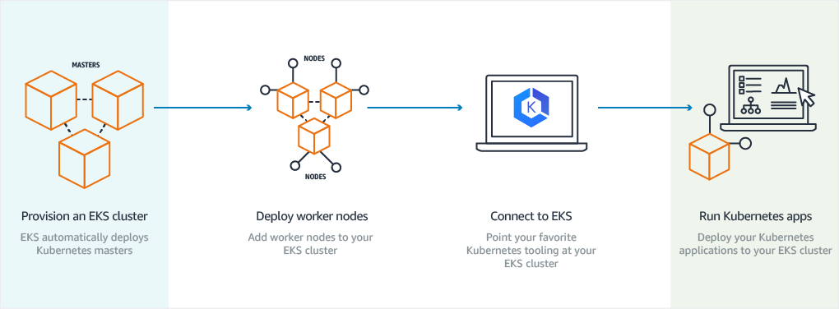

EKS is the best place to run Kubernetes for several reasons. First, you can choose to run your EKS clusters using AWS Fargate, which is serverless compute for containers. Fargate removes the need to provision and manage servers, lets you specify and pay for resources per application, and improves security through application isolation by design. Second, EKS is deeply integrated with services such as Amazon CloudWatch, Auto Scaling Groups, AWS Identity and Access Management (IAM), and Amazon Virtual Private Cloud (VPC), providing you a seamless experience to monitor, scale, and load-balance your applications. Third, EKS integrates with AWS App Mesh and provides a Kubernetes native experience to consume service mesh features and bring rich observability, traffic controls and security features to applications. Additionally, EKS provides a scalable and highly-available control plane that runs across multiple availability zones to eliminate a single point of failure.

* First create an Amazon EKS Cluster in the AWS Management Console or with the AWS CLI or one of the AWS SDKs.
* Then, launch worker nodes that register with the Amazon EKS cluster. We provide you with an AWS CoudFormation template that automatically configures your nodes.
* When your cluster is ready you can configure Kubernetes tools to communicate with your cluster.
* Deploy and manage applications on Amazon EKS Cluster the same way that you would perform with any other Kubernetes environment.

With Amazon EKS, you can take advantage of all the performance, scale, reliability, and availability of the AWS platform, as well as integrations with AWS networking and security services, such as Application Load Balancers for load distribution, Identity Access Manager (IAM) for role based access control, and Virtual Private Cloud (VPC) for pod networking.

Starting with the task

Install eksctl.exe and provide path in the environmental variables

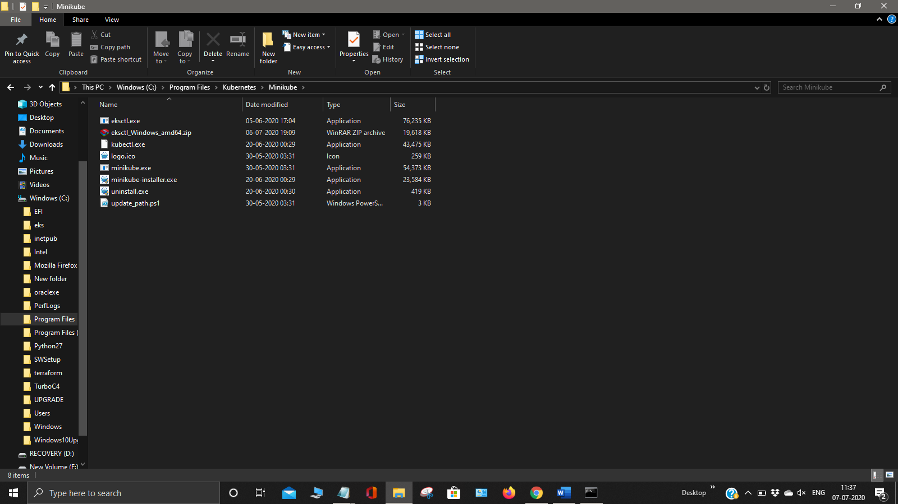

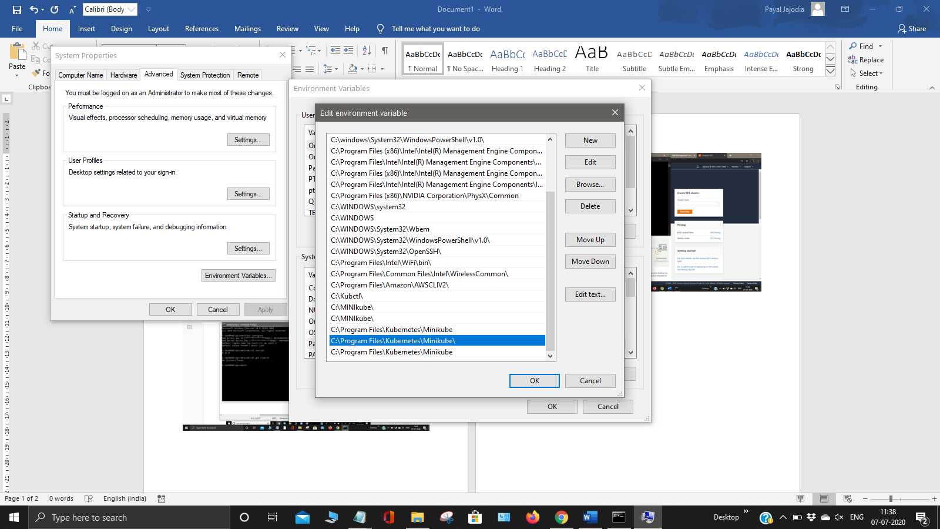

First login to your AWS account by providing the access key ID and secret access key.

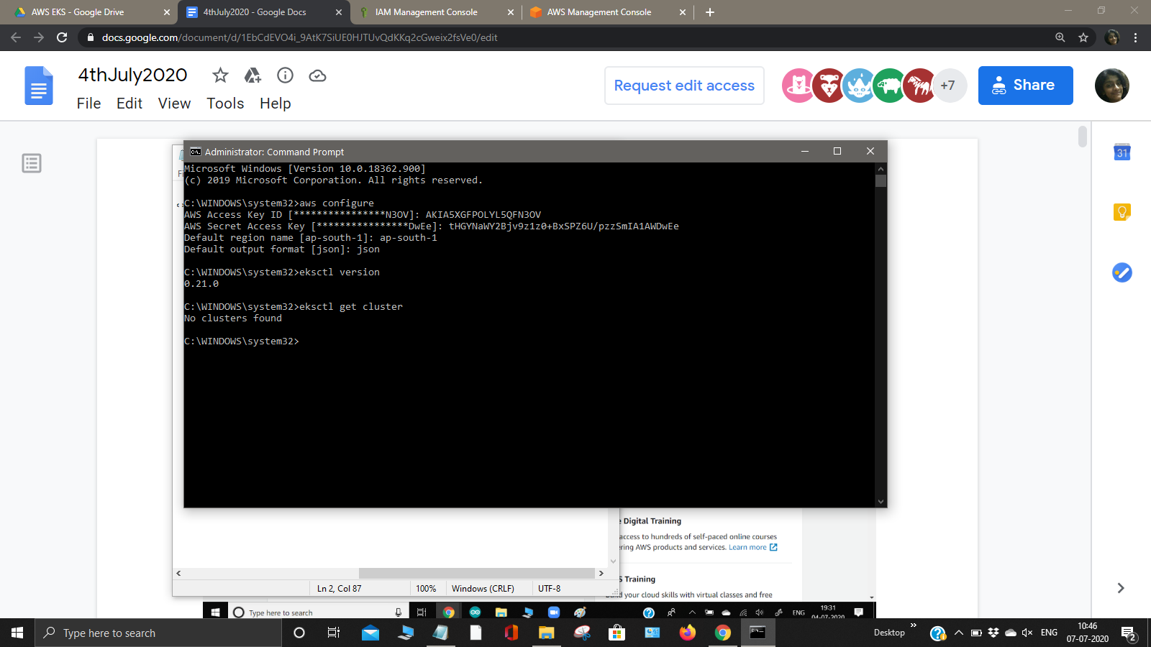

Now create a folder on desktop by name eks_class_cloud and create a notepad file by name cluster.yml

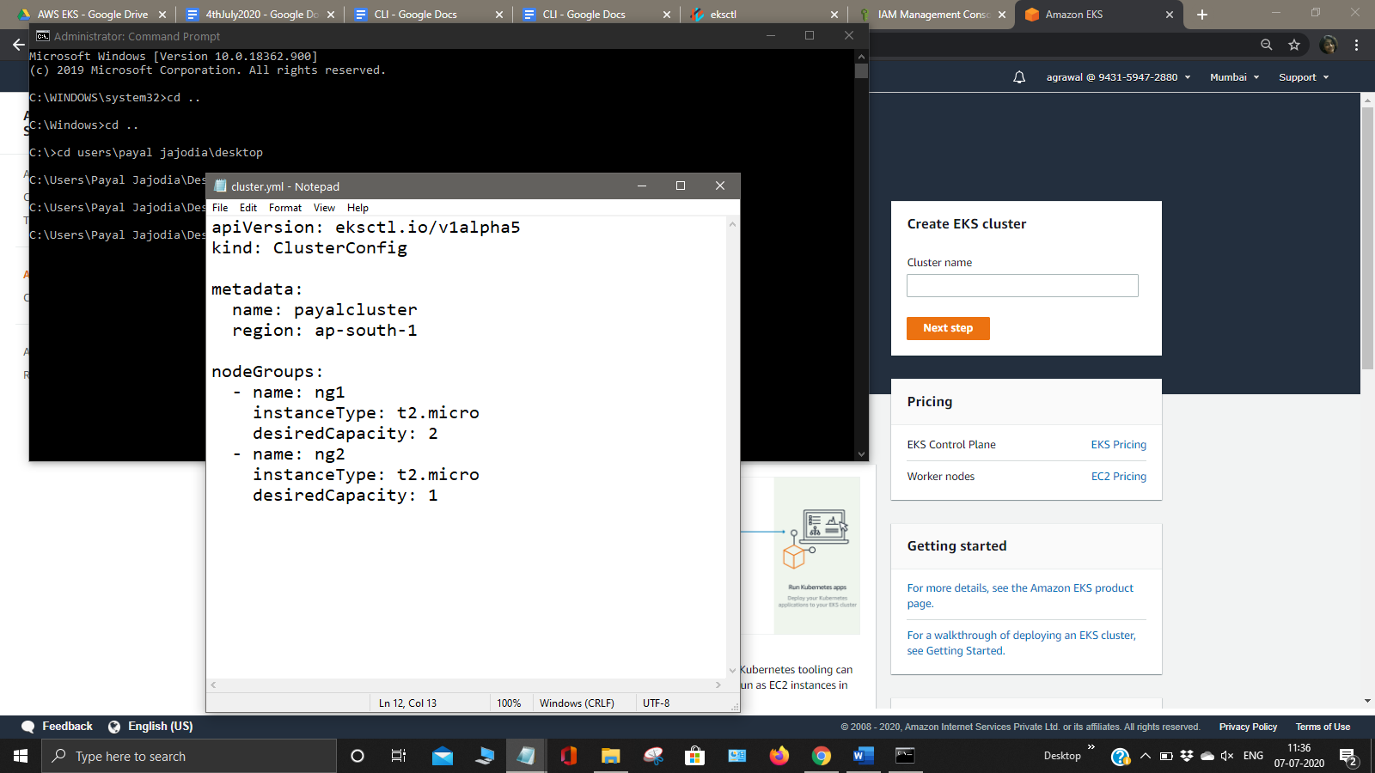

Now create cluster by deploying the notepad file using the command create cluster -f cluster.yml

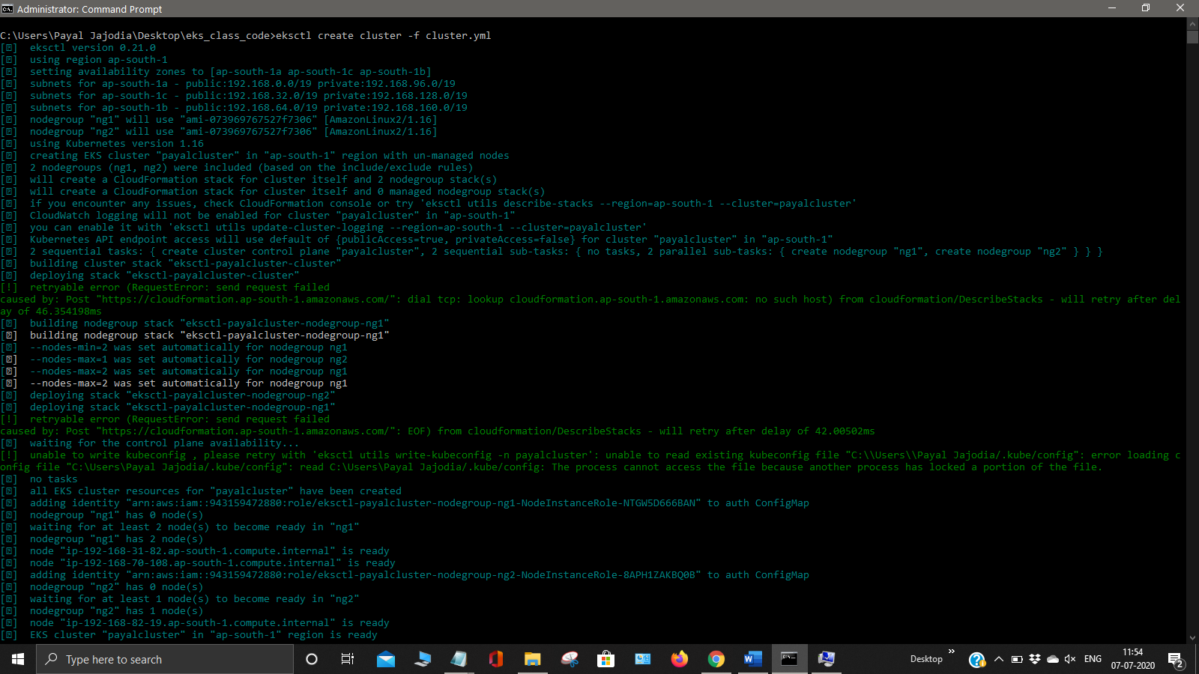

The cluster name payalcluster will be created .

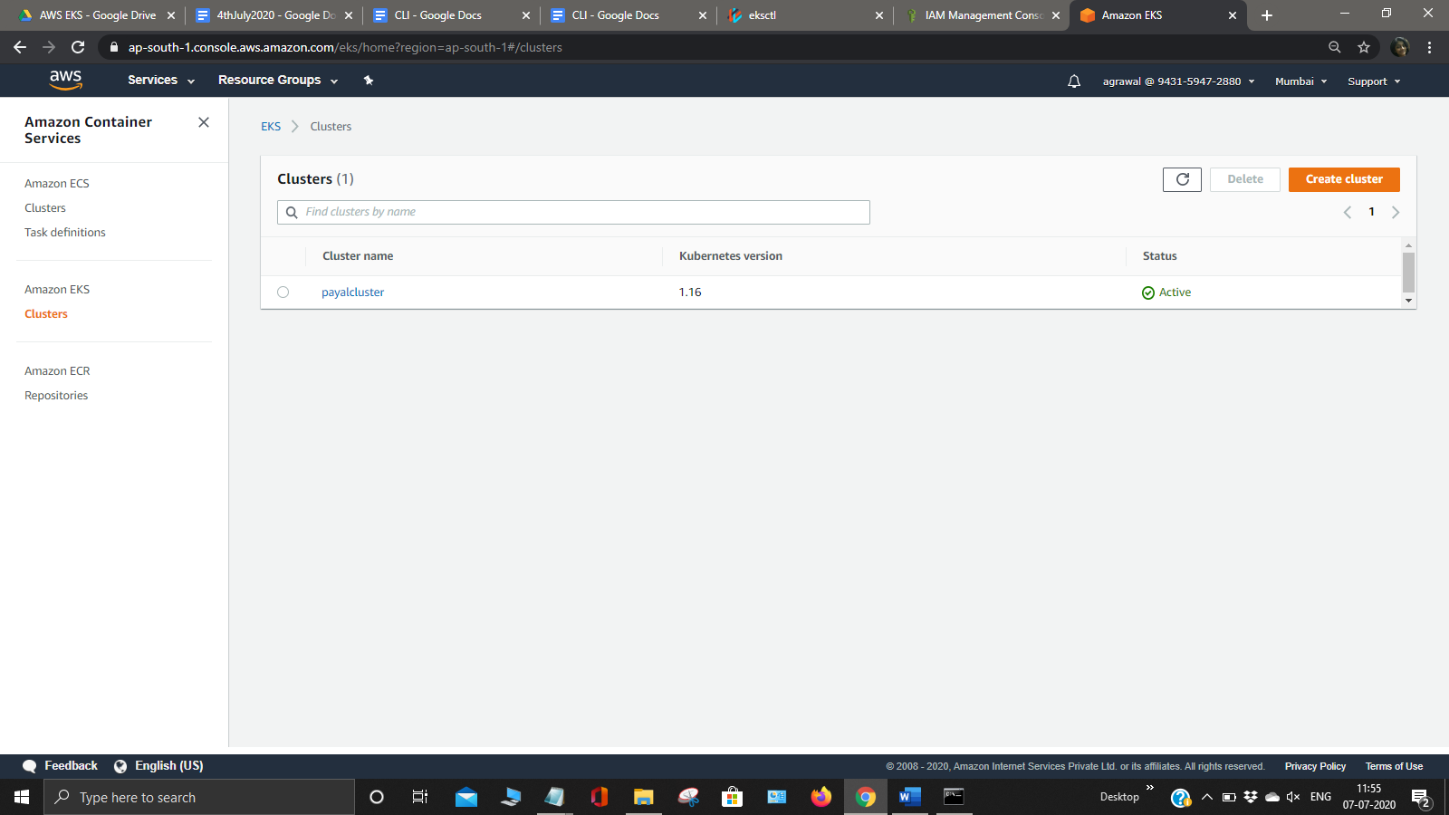

Eksctl program internally creates cloudformation astack for cluster automatically.

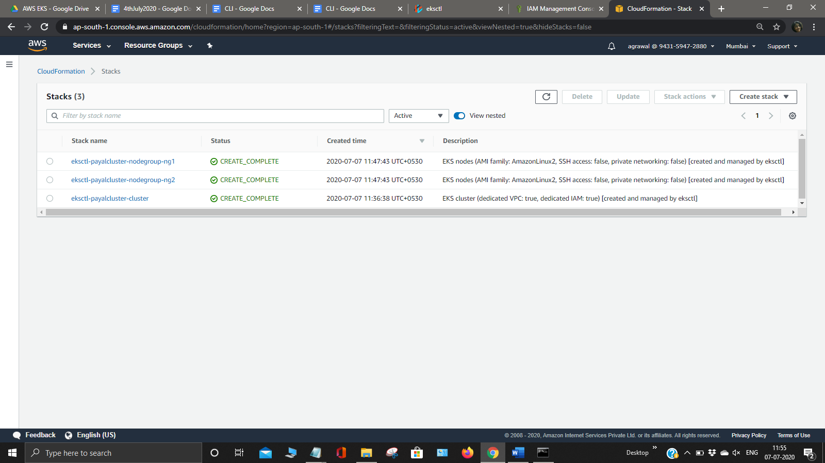

Now open another command prompt and type the command kubectl config view and it will list certain things. For connecting to the master we require configure file that contains IP , username and password. AWS automatically creates this file and we can view the config file using

aws eks update-kubeconfig –name cluster .

Now update your ekscluster i.e. payalcluster

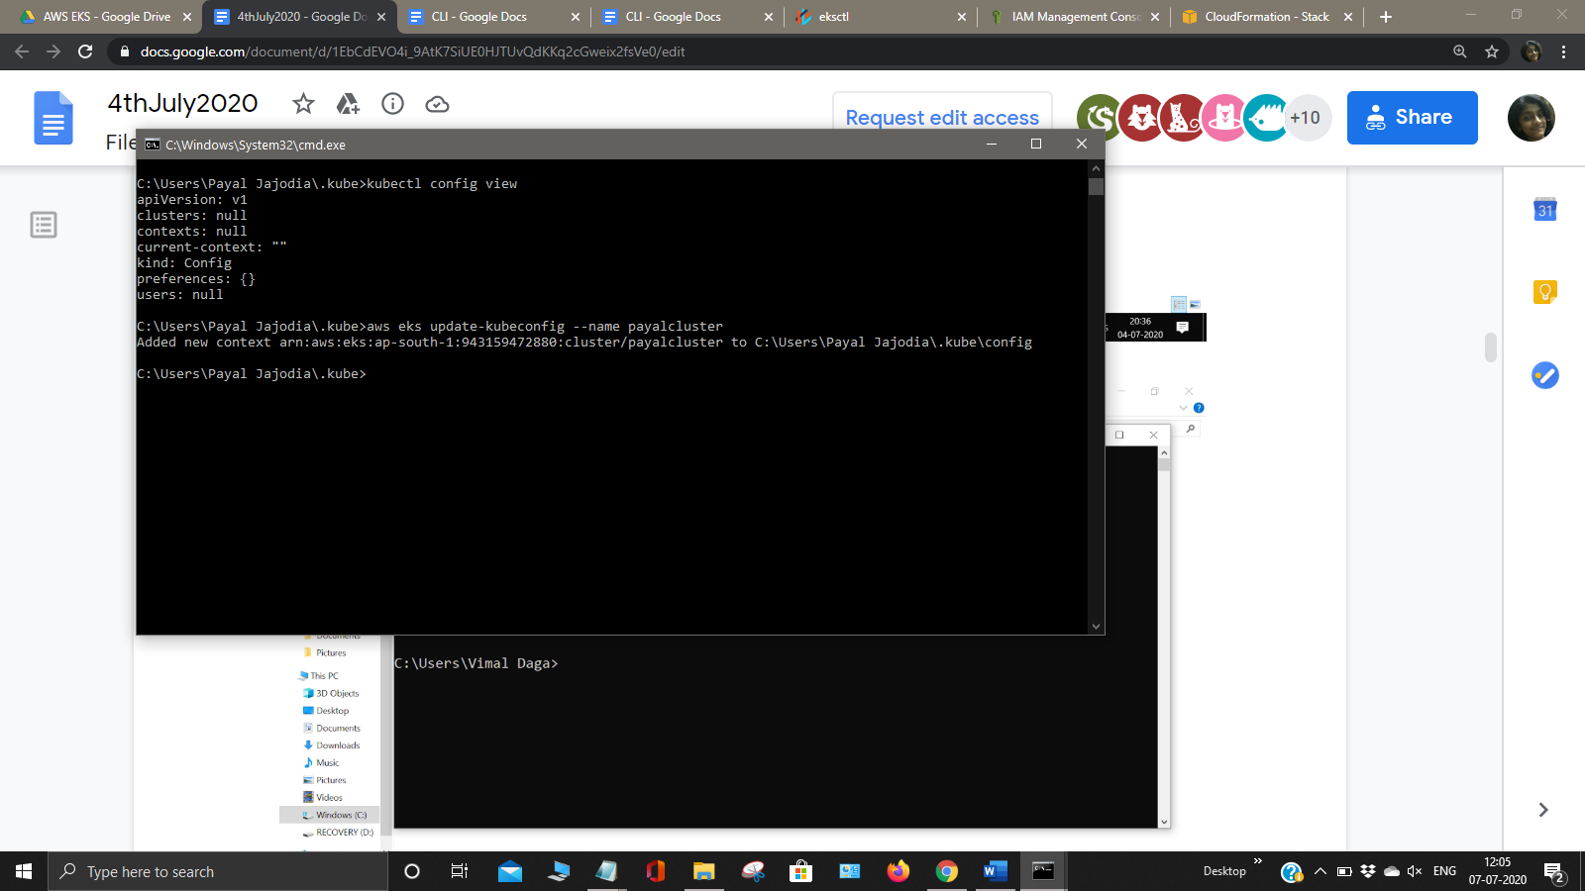

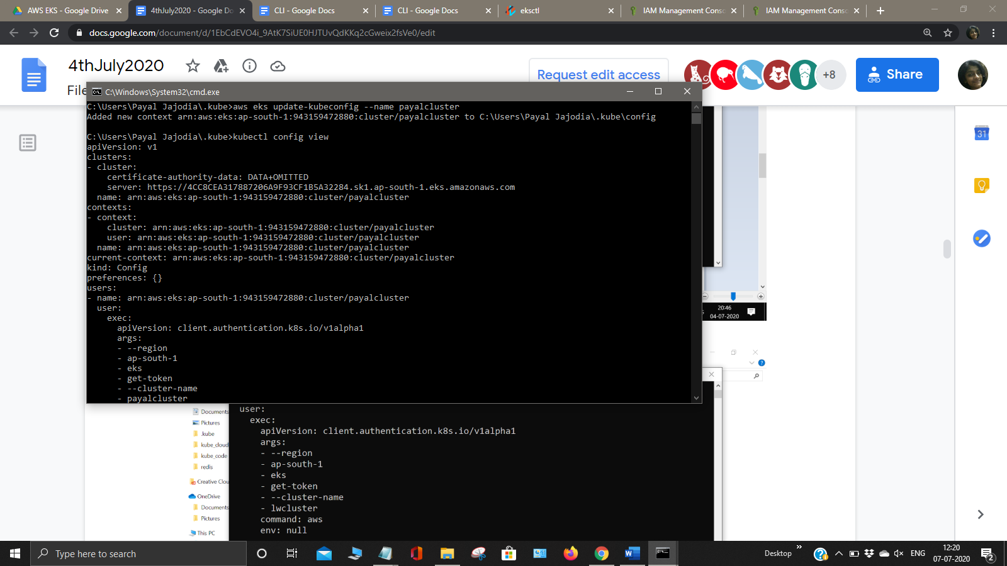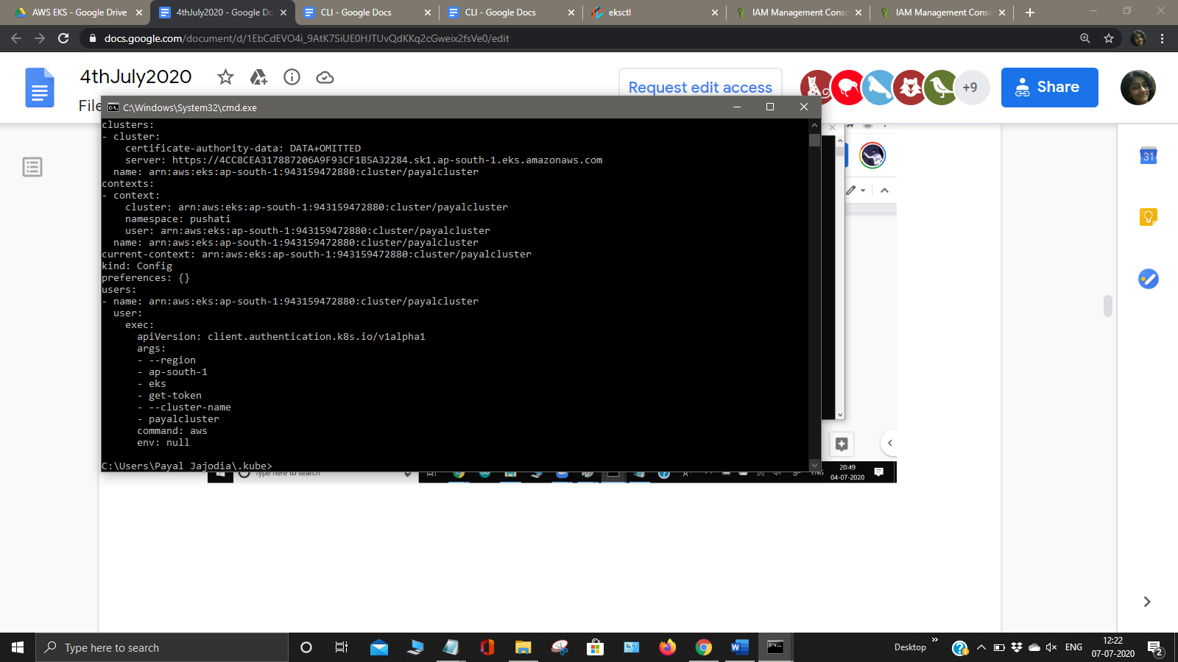

In the eks_class_cloud a config file will be automatically created as shown below.

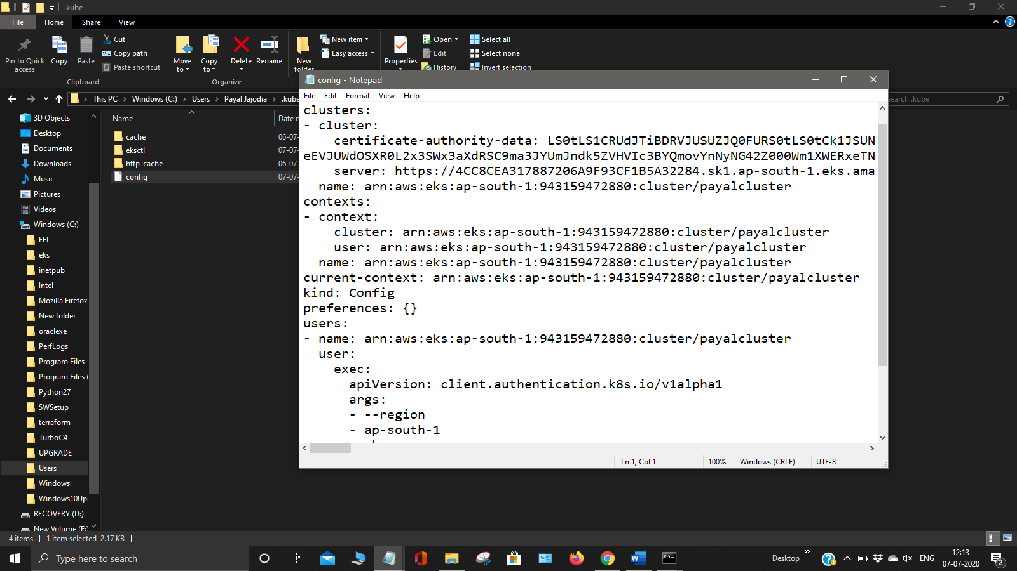

Now we can check that the cluster made using the command eksctl get cluster to get all the clusters. Now get the pods and nodes to get all the pods bynusing command kubectl get nodes or kubectl get pods.

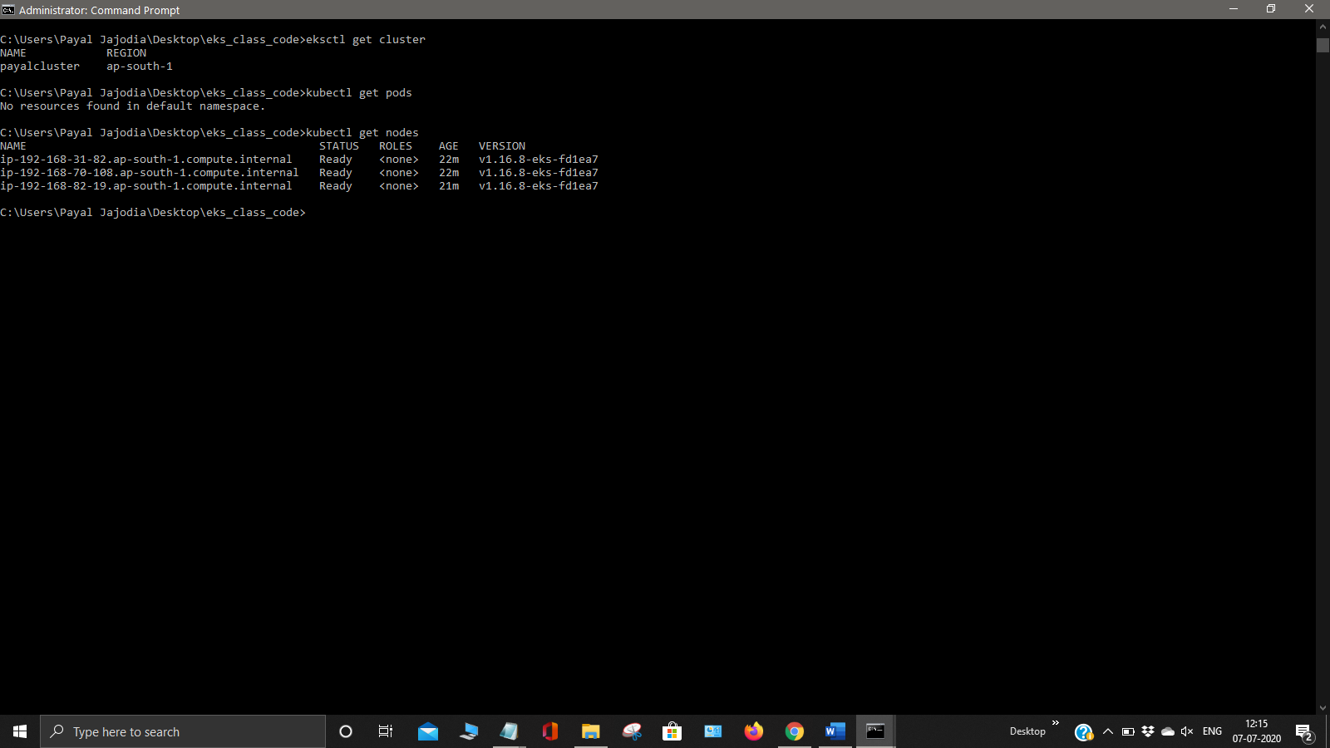

Now we can describe the nodes that we get using the command kubectl describe <node name>

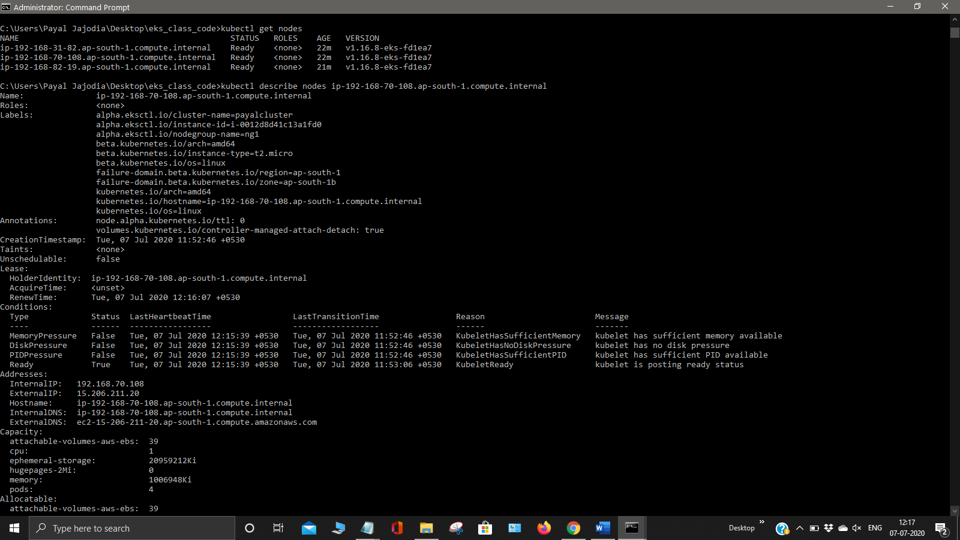

Now we have to create a namespace by the command eksctl create namespace <name>.

We can also check the namespaces created using the command kubectl get ns

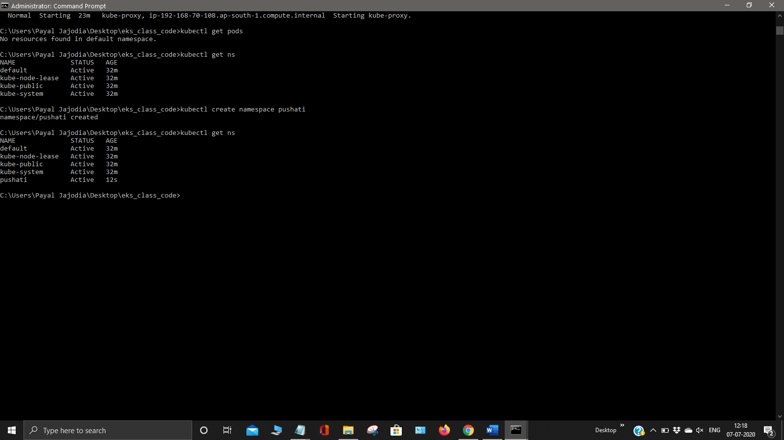

Now get cluster info by the use of the command kubectl cluster-info

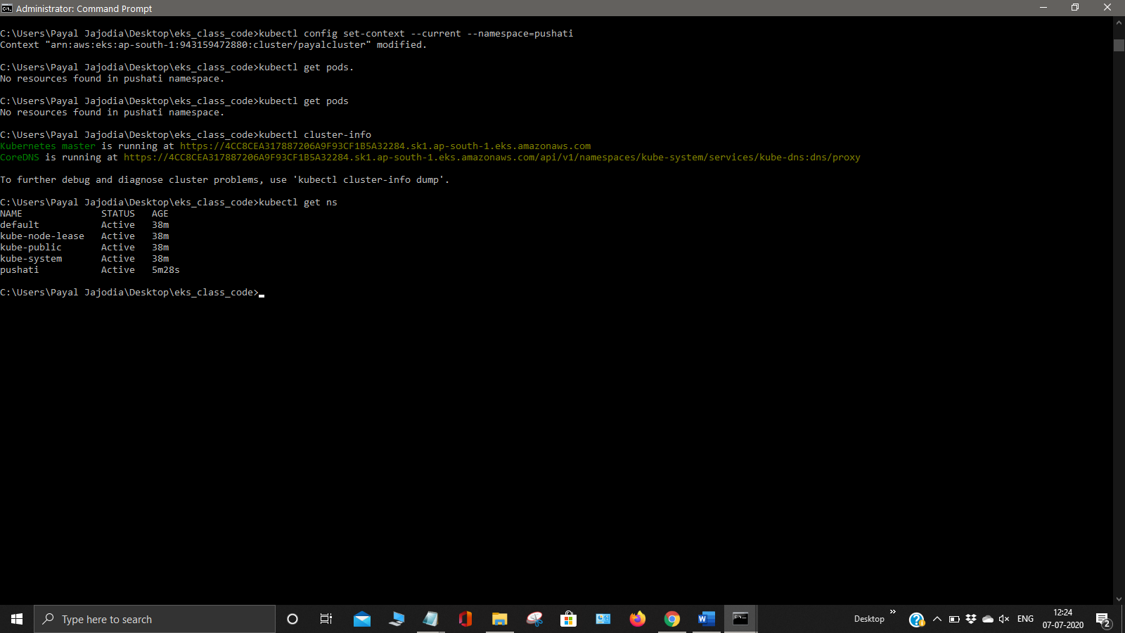

Now get create deployment by using kubectl create deployement myweb1 –image=vimal13/apache-webserver-php

Now get all pods and all the nodes using the command kubectl get nodes and kubectl get pods

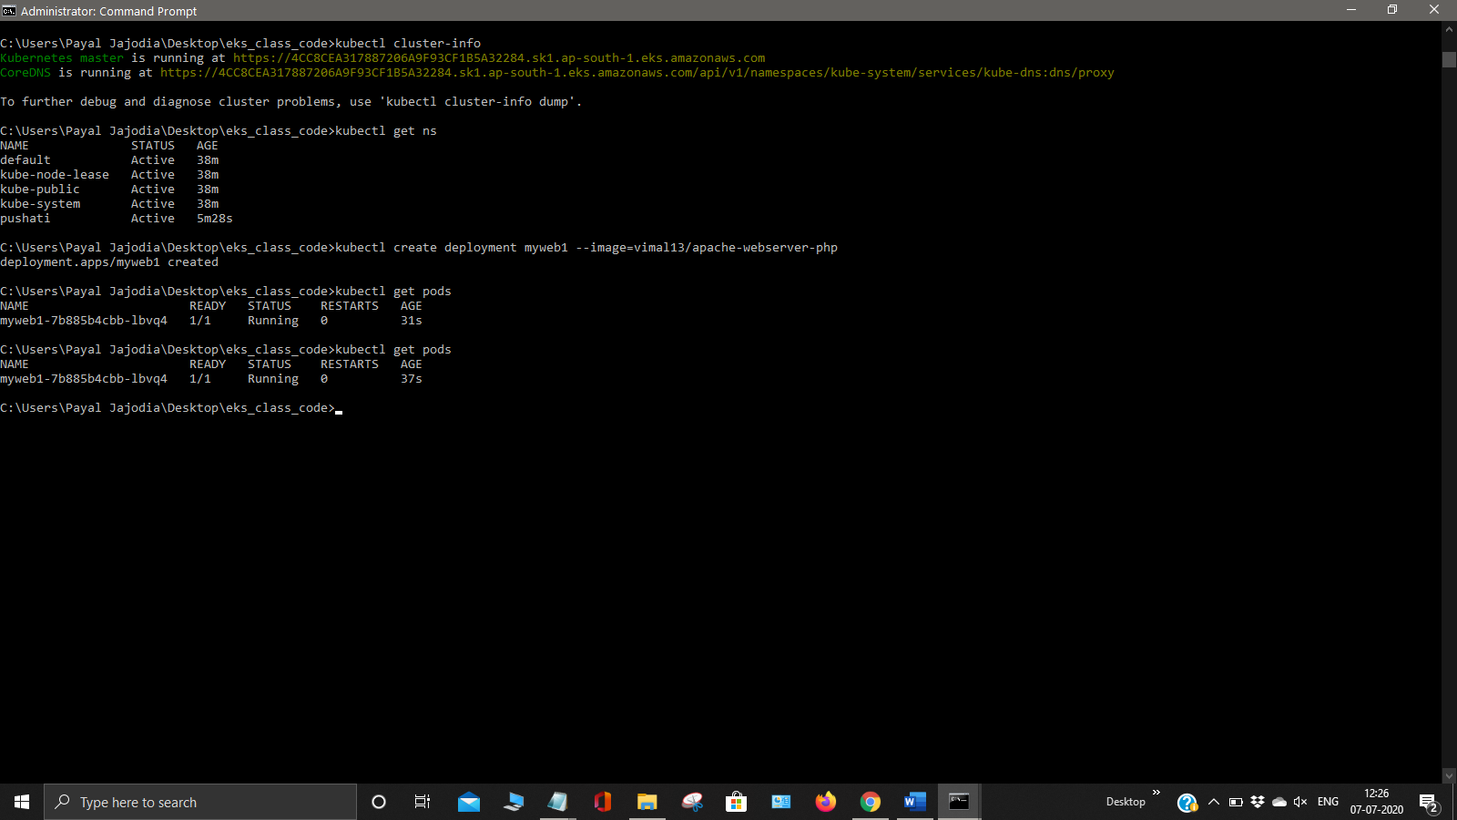

Now get detailed information of the nodes using the command kubectl get pods -o wide. And also get the replicas by using the command kubectl create deployment myweb1 –replicas = 3

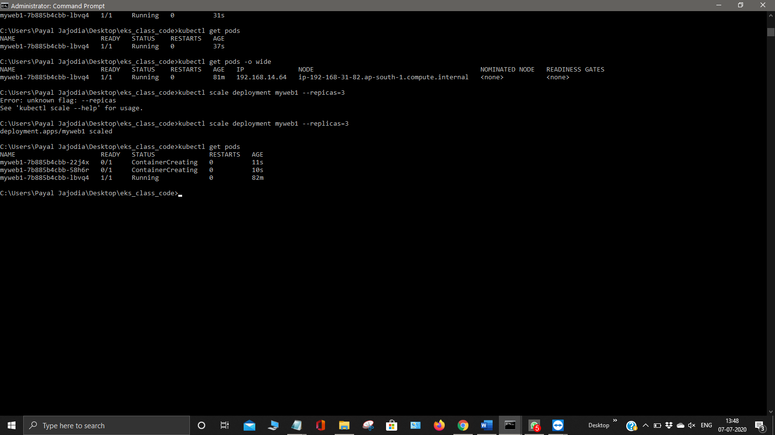

Now expose your deployment scale it with the help of load balancer by using the command kubectl expose deployment myweb1 –type LoadBalancer –port =80.

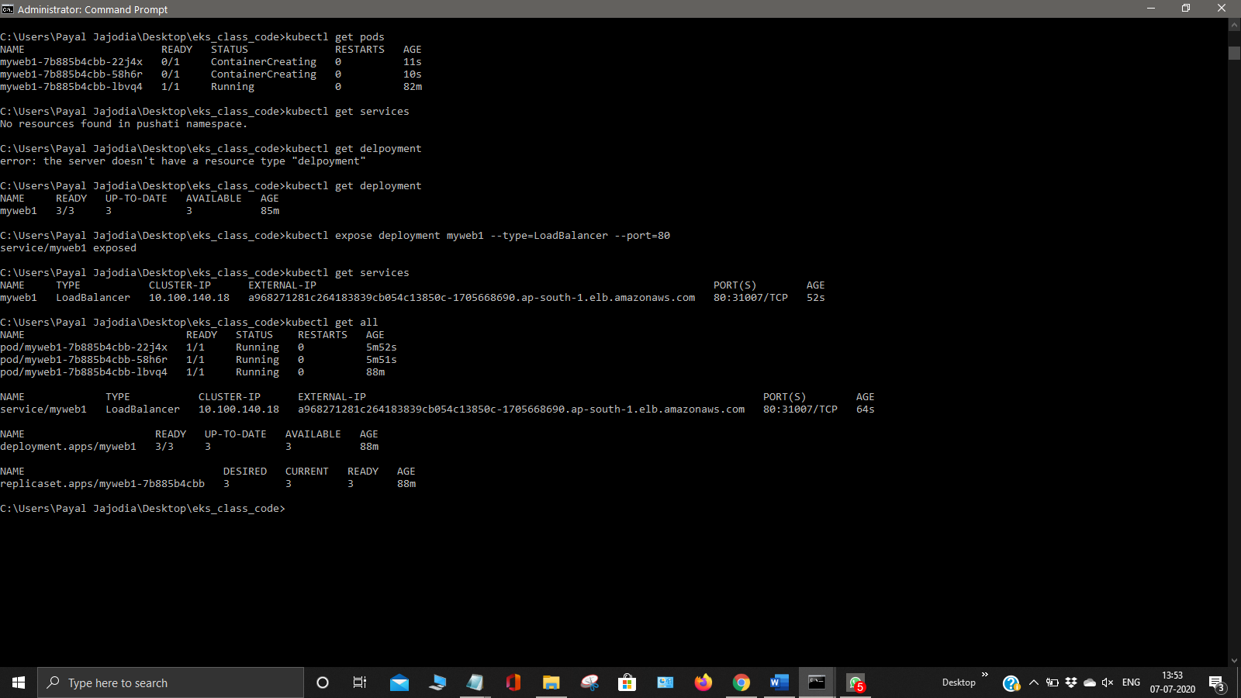

Now get your all pods using the command kubectl get all and to describe the webserver use the command kubectl describe service/myweb1.

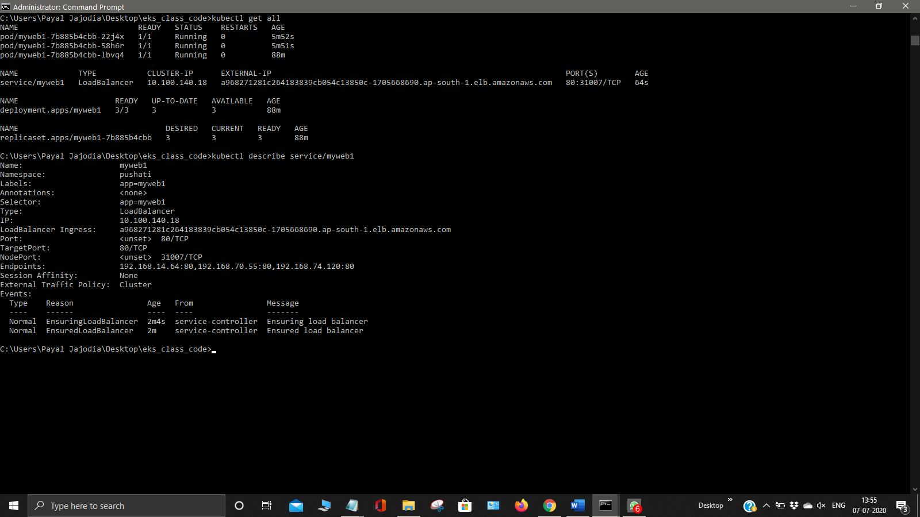

Now go to your console and check for the instances created

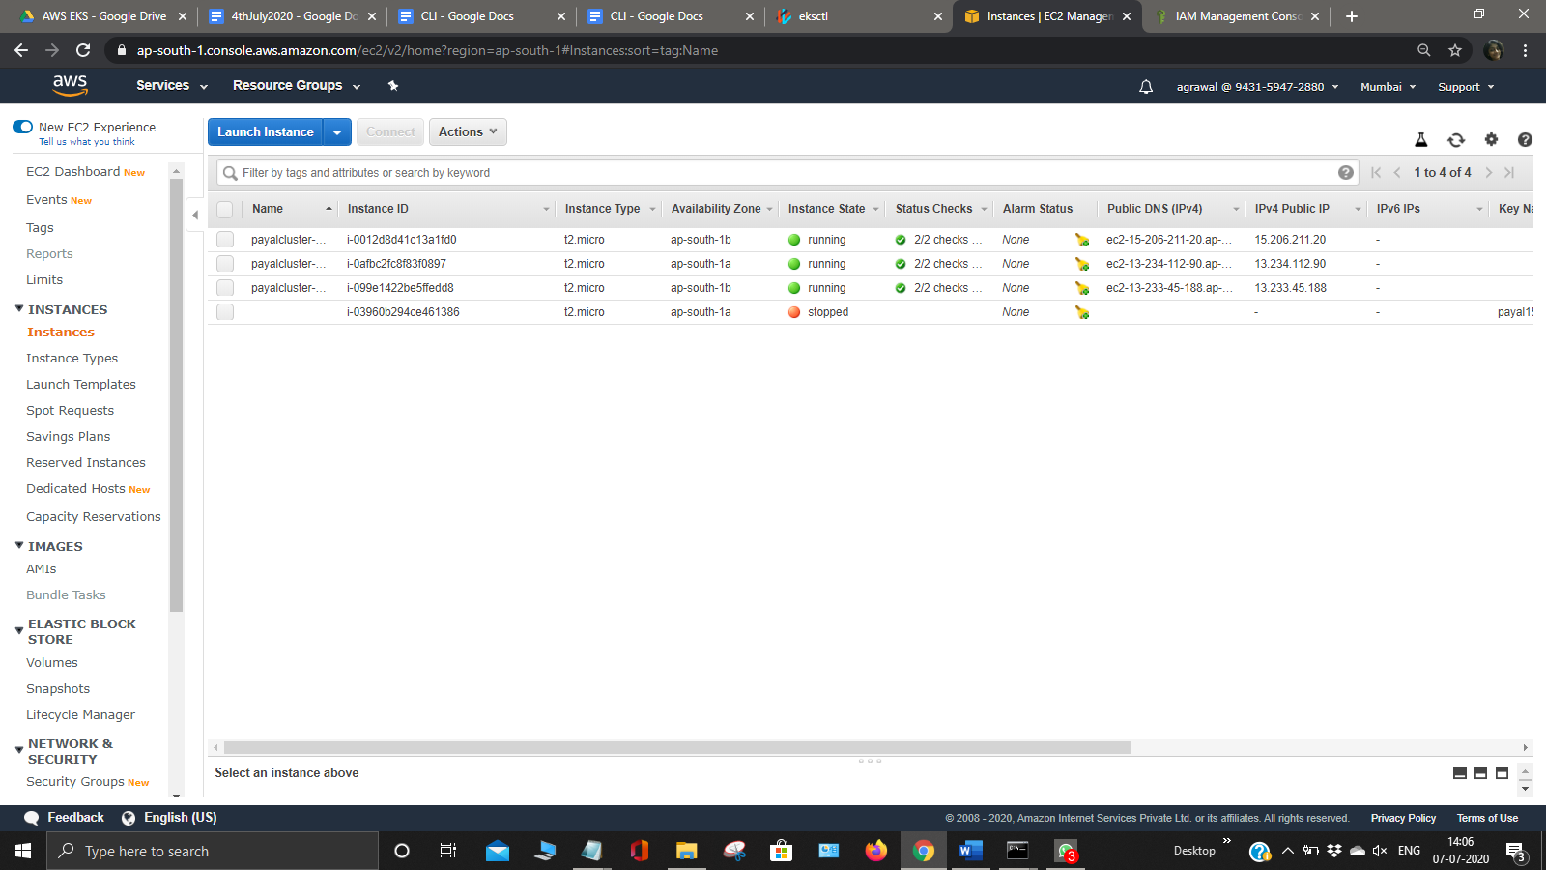

Go to your security groups and check for the new eksctl security groups created.

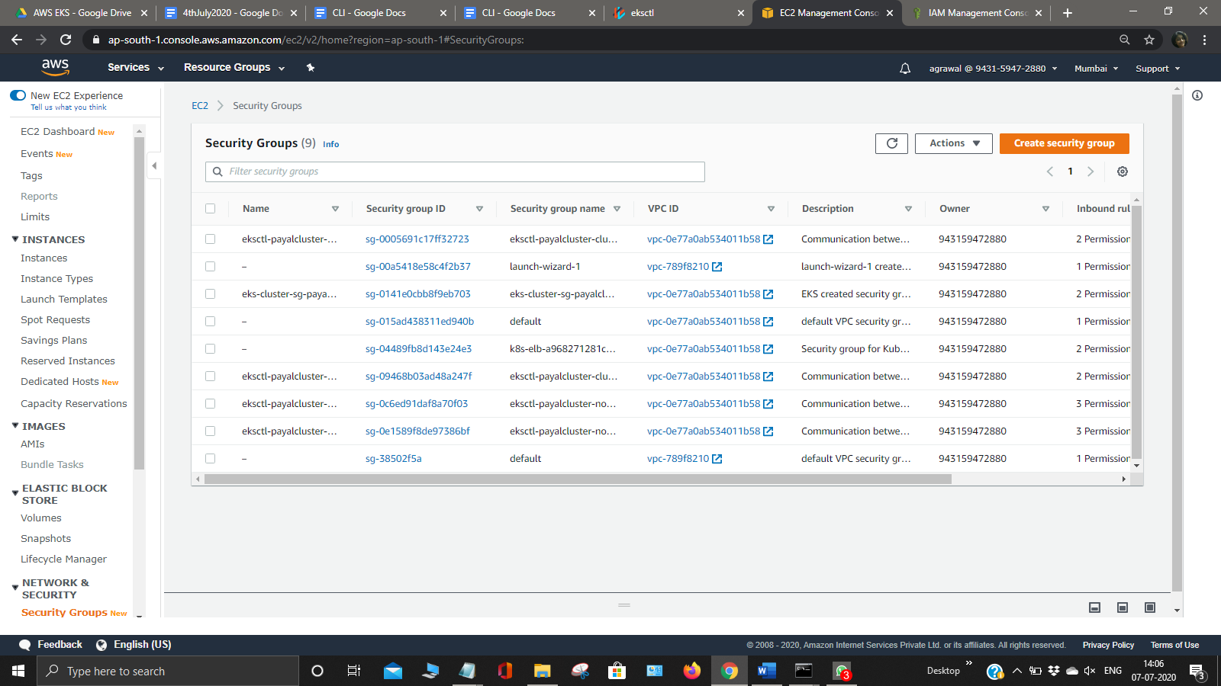

Now check for the volumes created by the eksctl cluster and Load Balancer

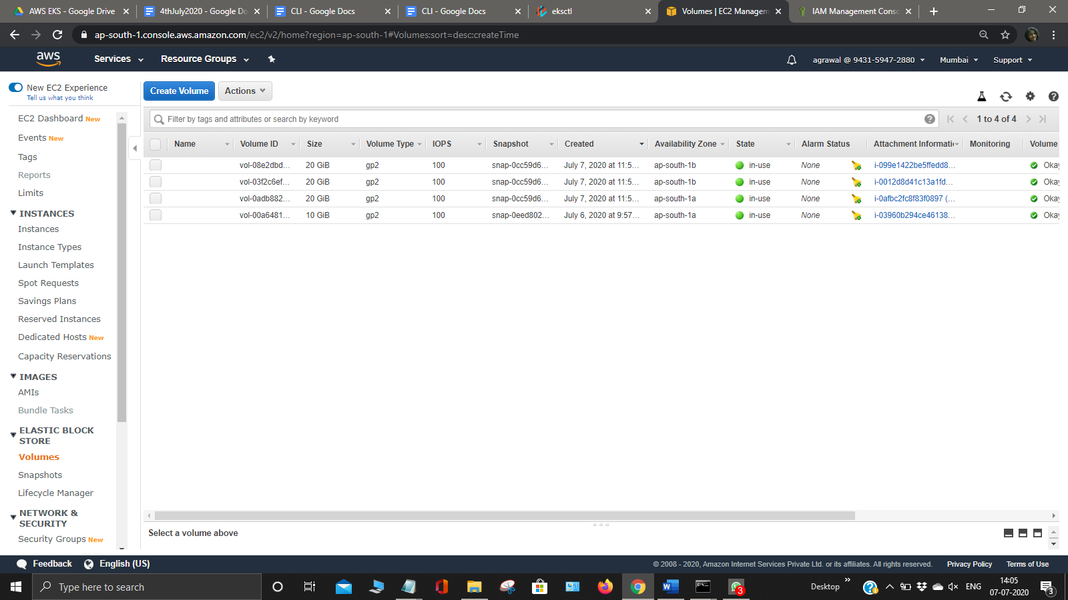

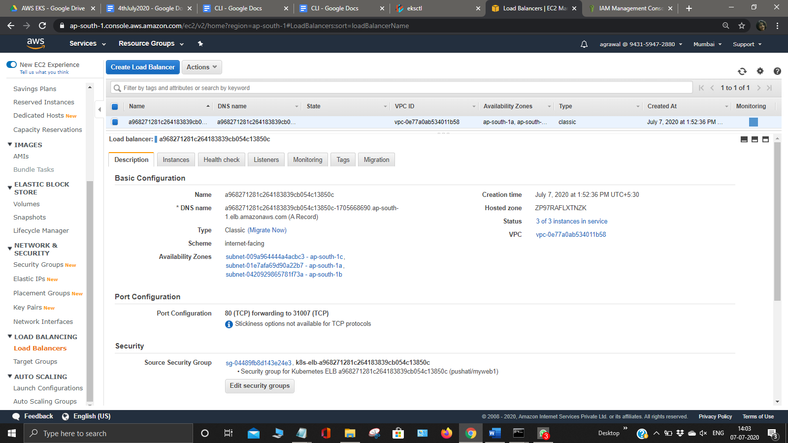

Also check for the Elastic IP created by the eksctl cluster and also the network interfaces.

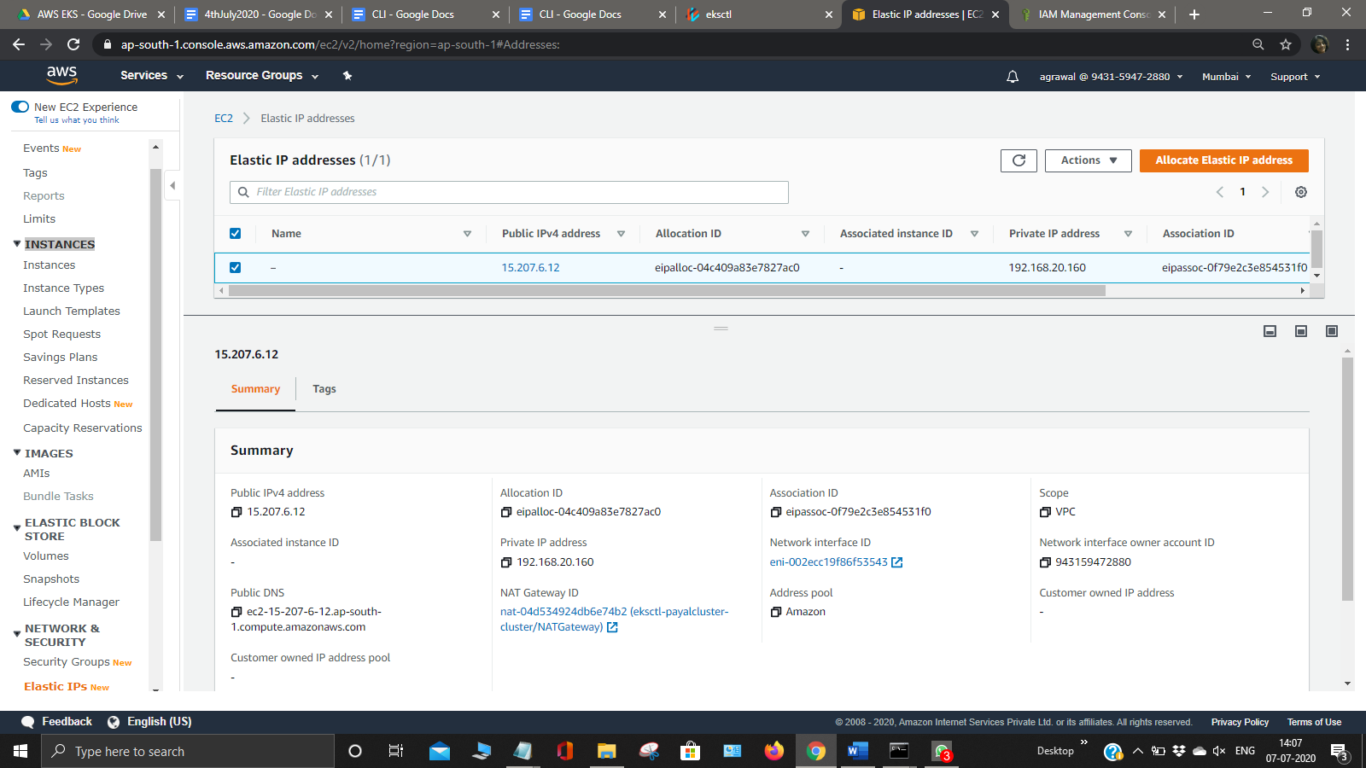

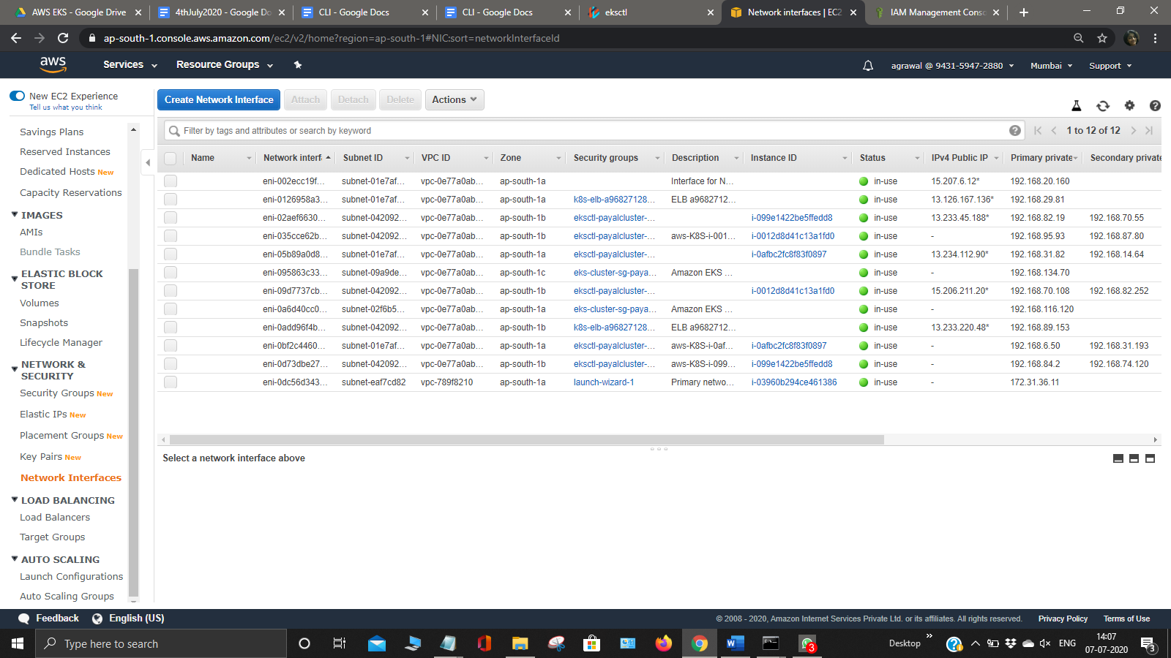

Now use anyone of the Load Balancer URL and browse it you will get following screen.

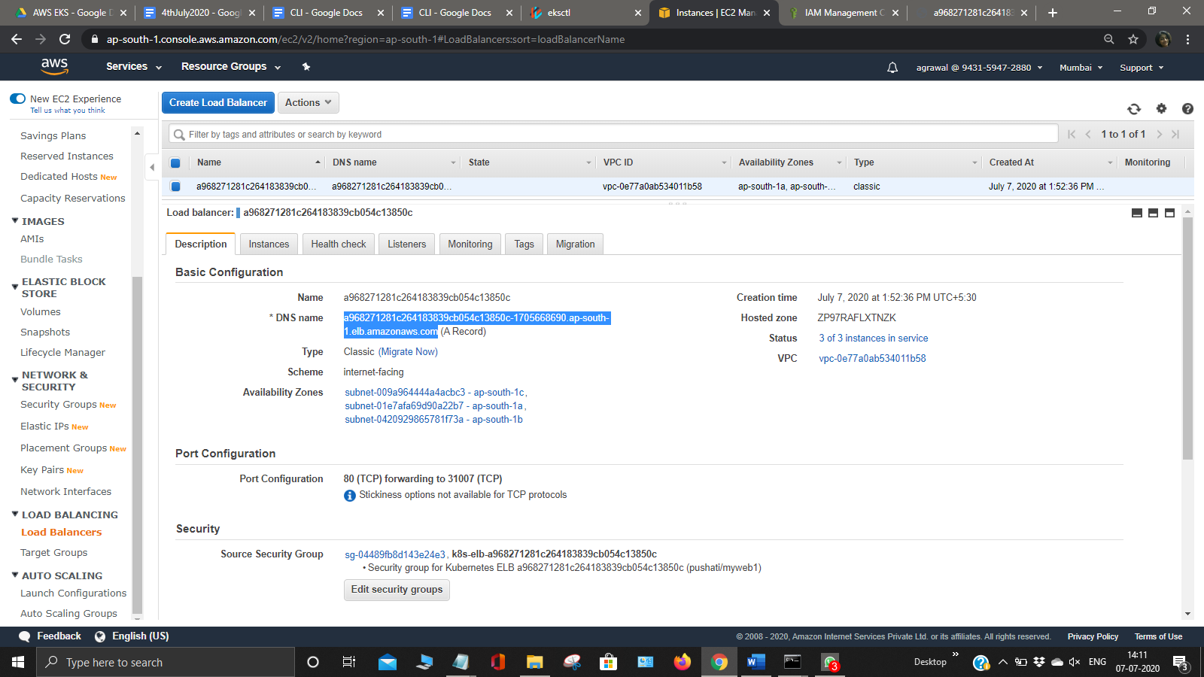

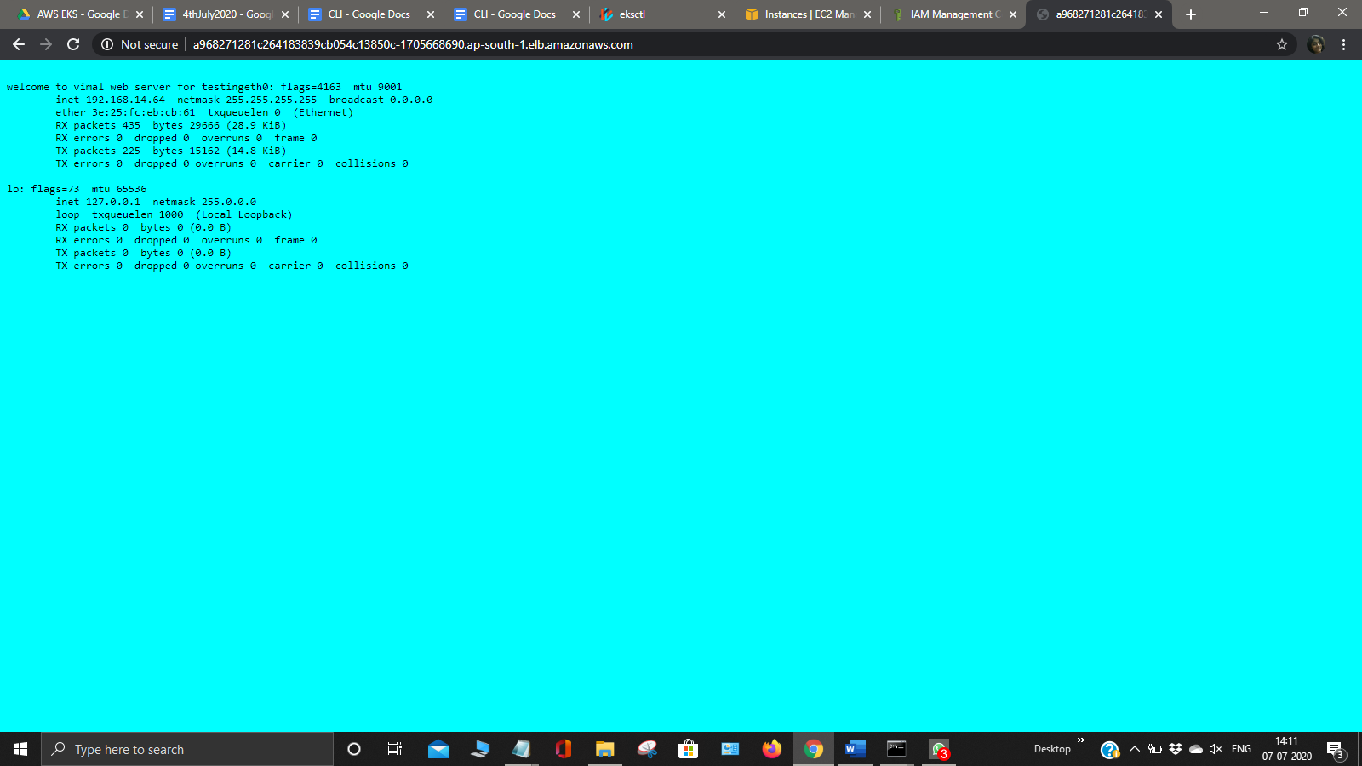

Now get all the services using kubectl services

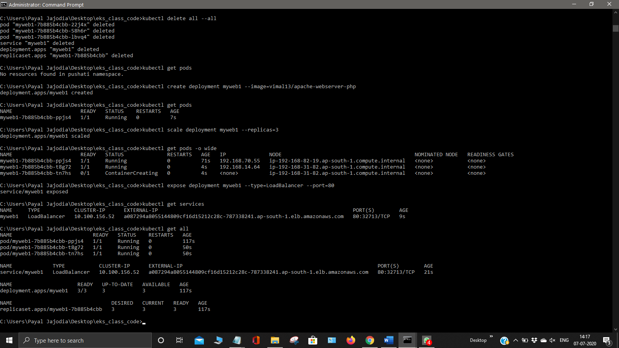

Now go to your one of the pods using kubectl exec -it podname –bash command and update one of your index.php file to see the working of Load Balancer .

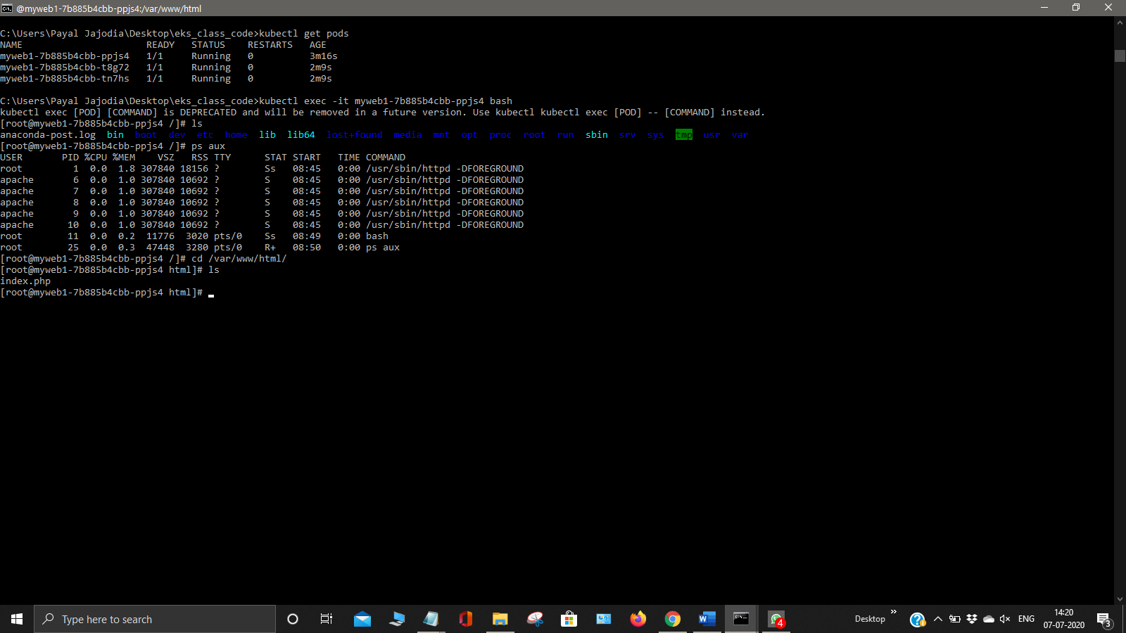

Now copy this to var/www/html

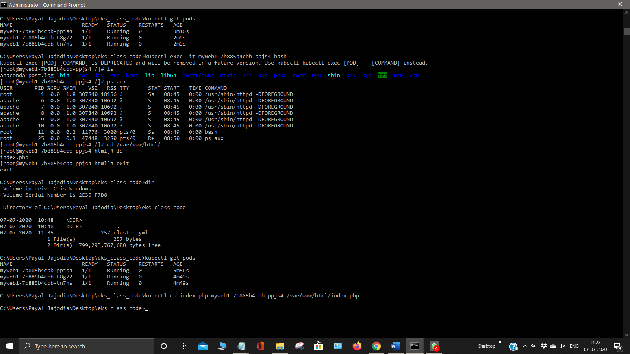

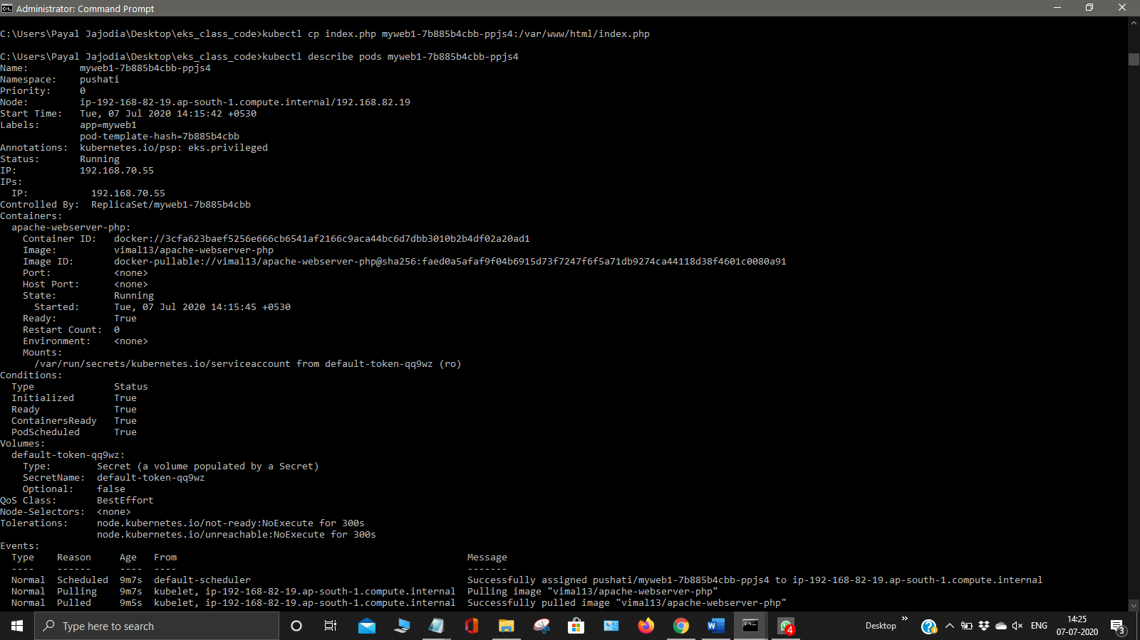

Now edit the sc gp2 using kubectl describe sc gp2

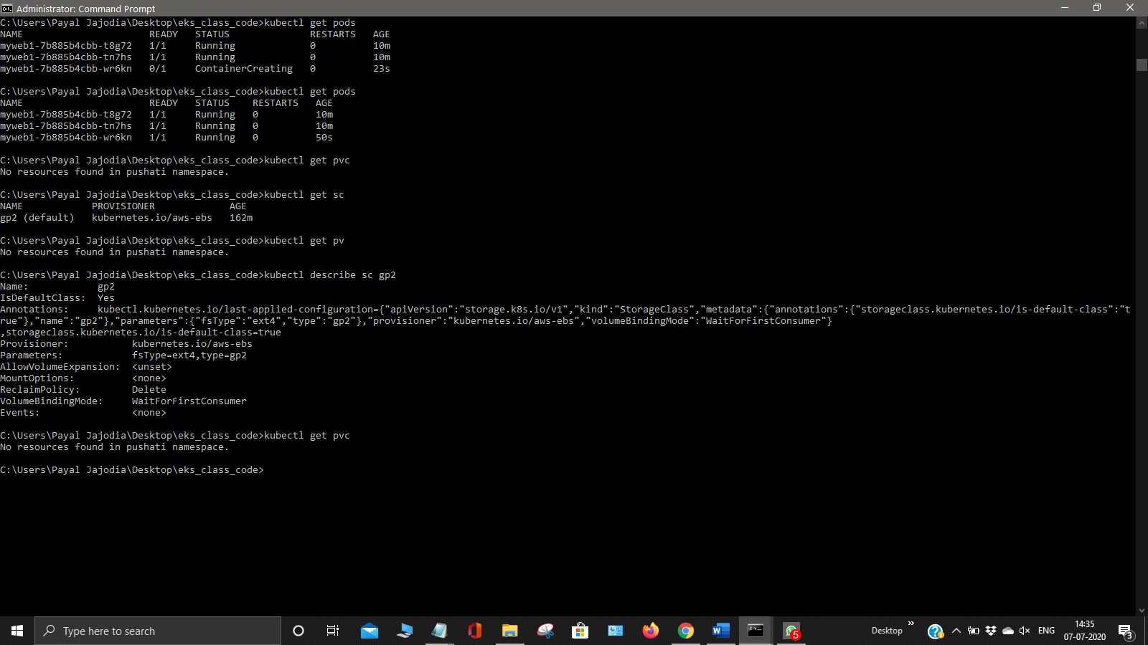

Now get the storage class using kubectl get sc

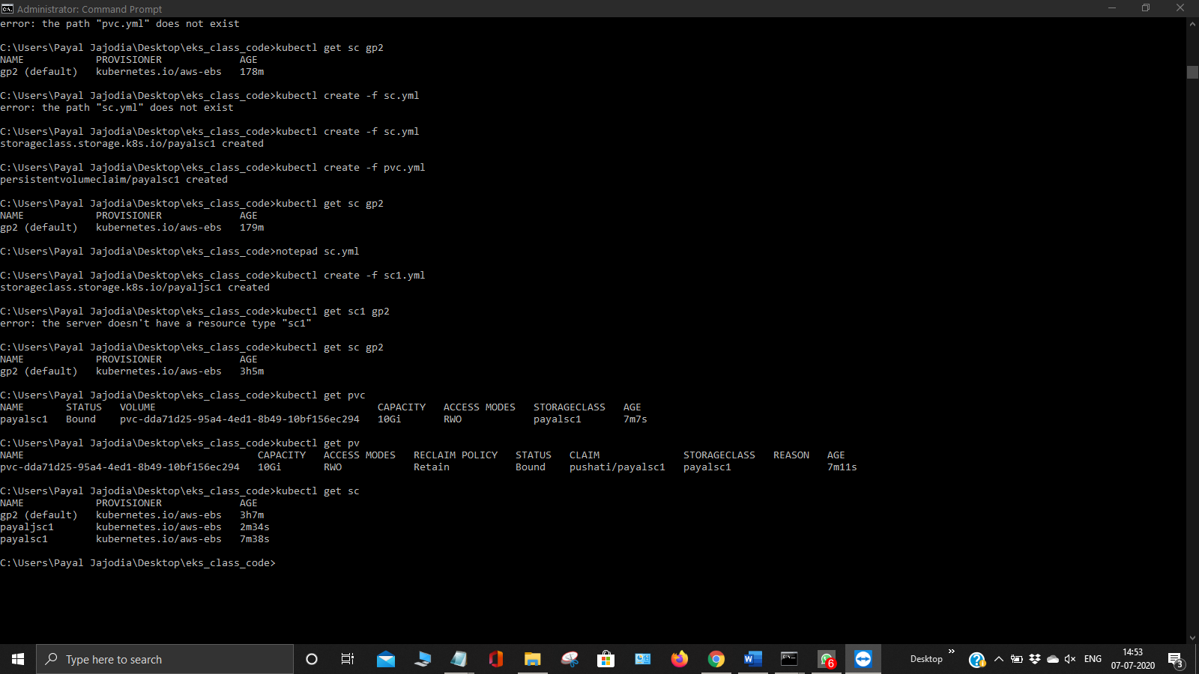

Also create sc and pvc file using kubectl cluster -f sc.yml and kubectl cluster -f pvc.yml

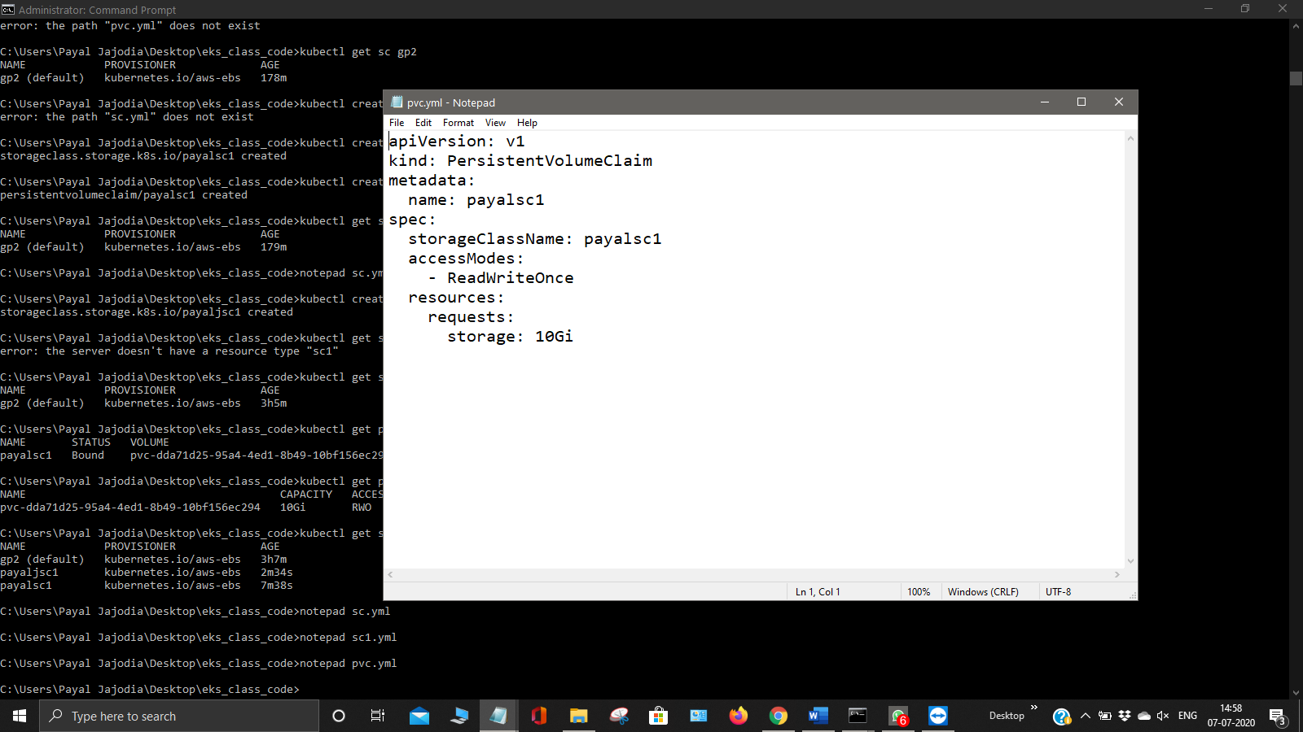

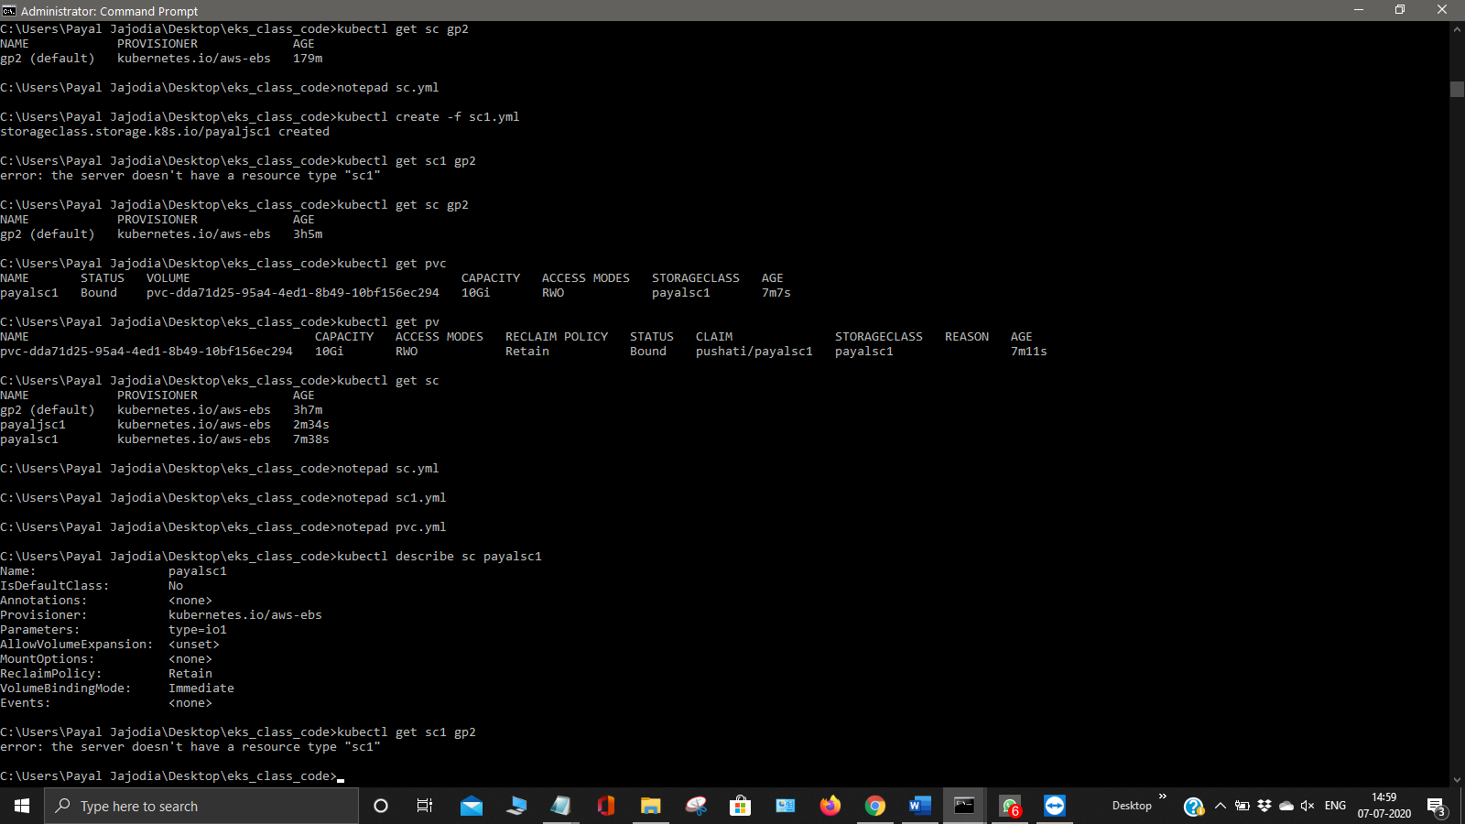

Now get all the node groups and also scale them . Use the command eksctl get nodegroup –cluster <name of cluster>

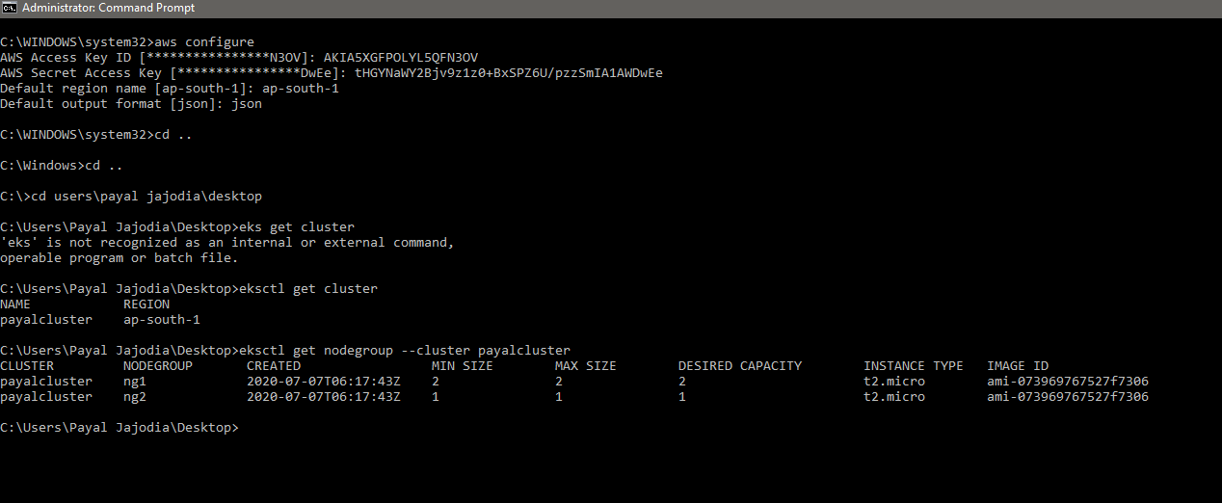

Now scale the nodegroup using the command eksctl scale nodegroup –cluster <name of cluster> ng2 –nodes-max=5

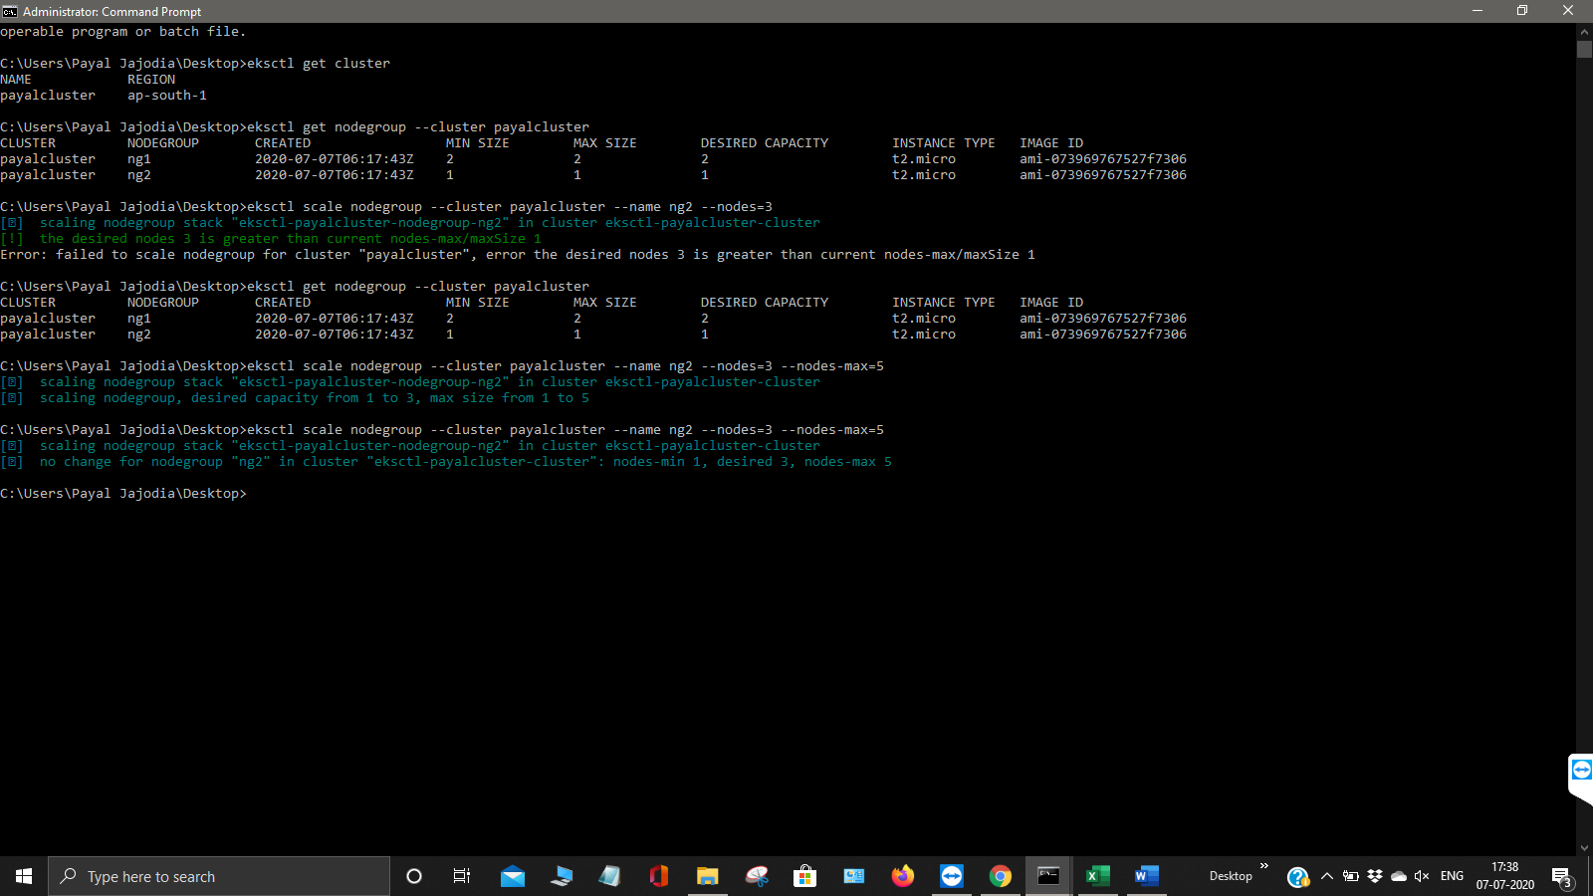

Now go to one of your node group and run your namespace using the command ssh -I keyname ec2-user -i <ip>

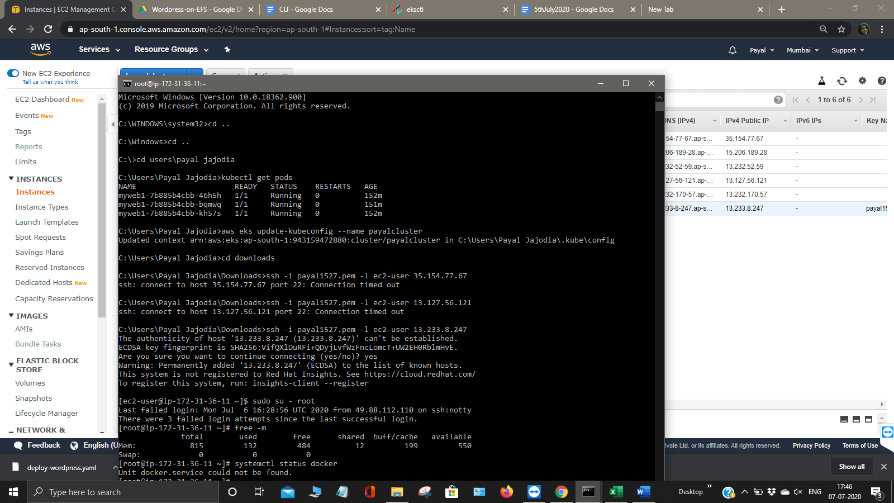

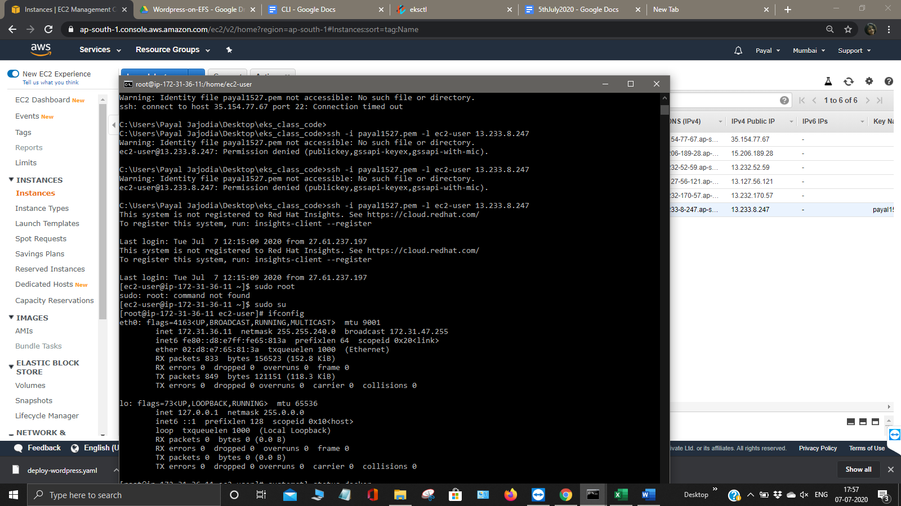

For checking how many pods are running in the namespace use the command kubectl get pods -n kube-system

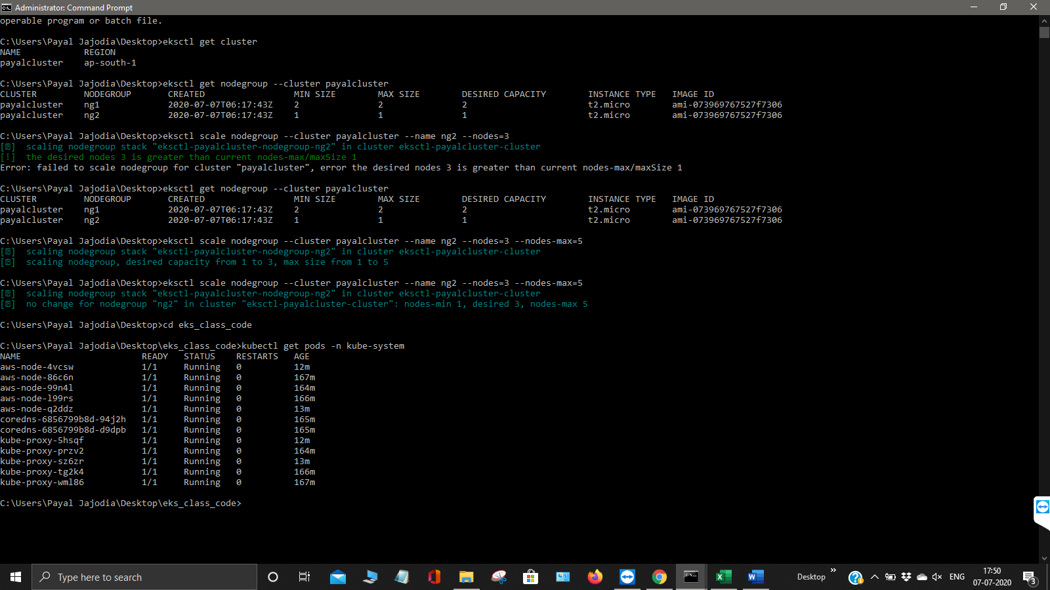

Now we will create Wordpress and MySql Multitier architecture on the top of EKS with the help of kustomization.yml file using the command kubectl create -k.

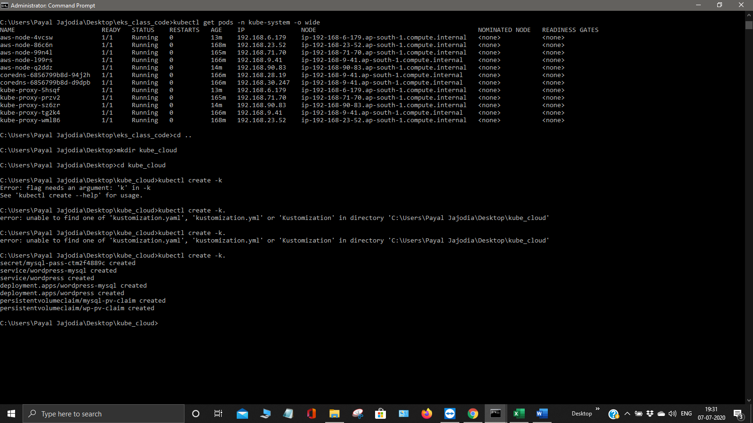

Now get the pods and the pv using following commands as mentioned inn screenshot.

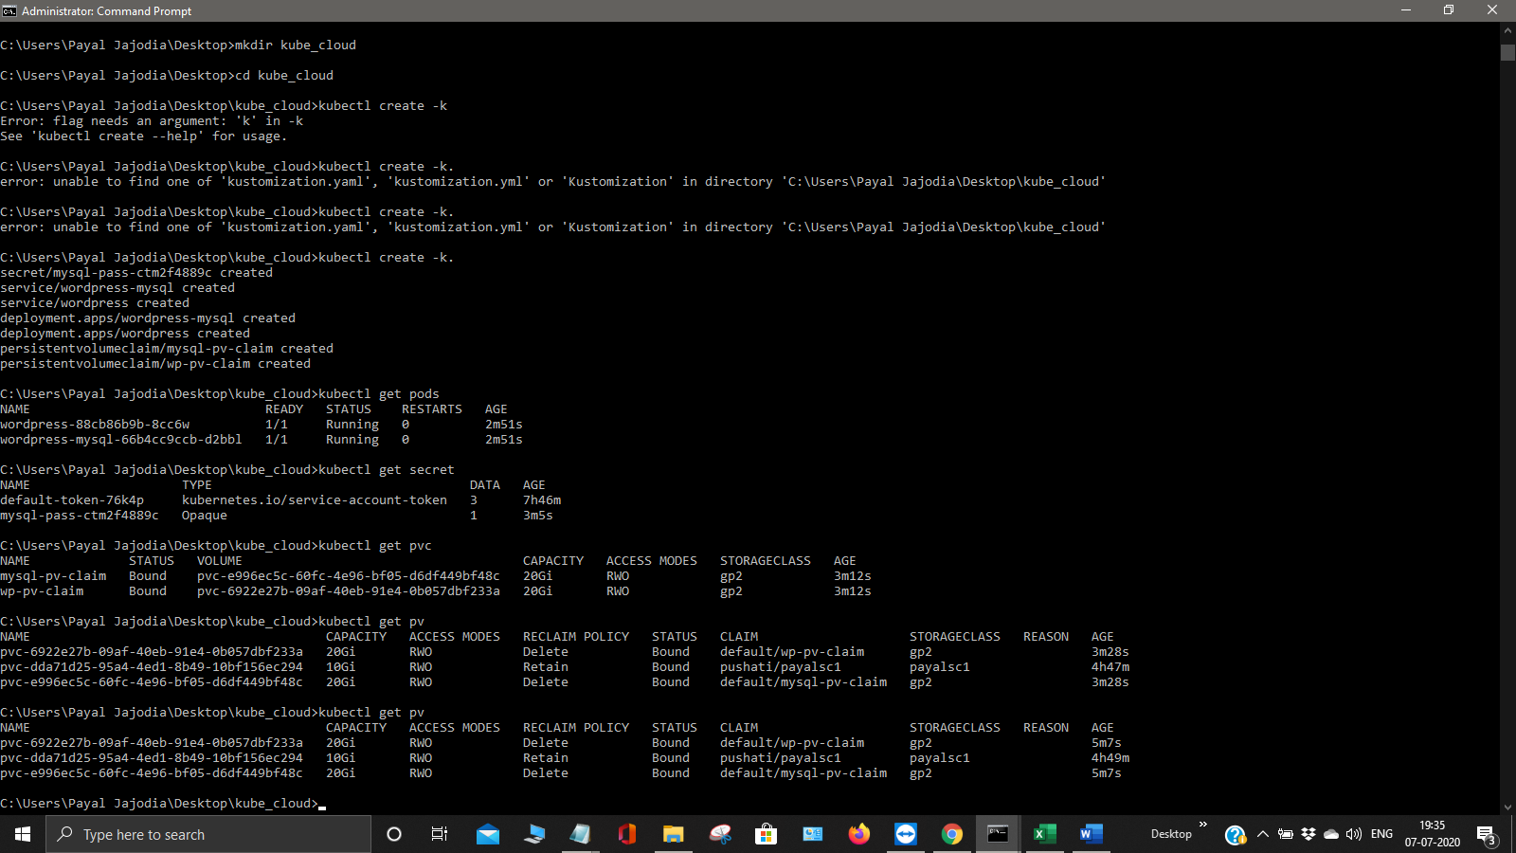

Now we can see that complete multitier architecture is deployed with the wordpress and mysql pods, services, load balancers.

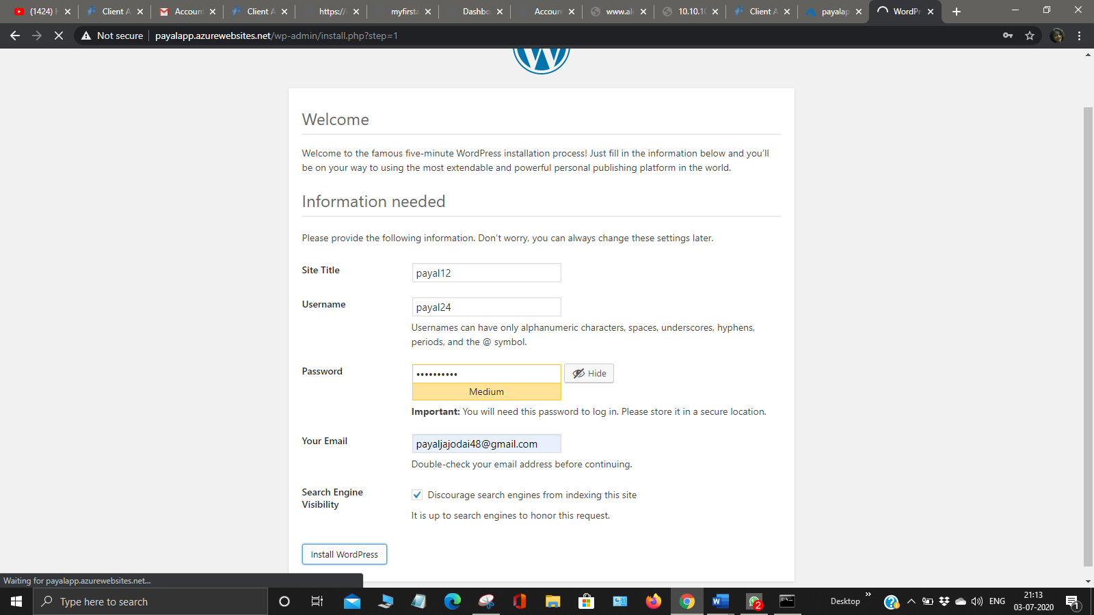

Go to your console and create a EFS as mentioned below in the screenshot.

Also configure your ekscluster NodeGroup with the inbound rules.

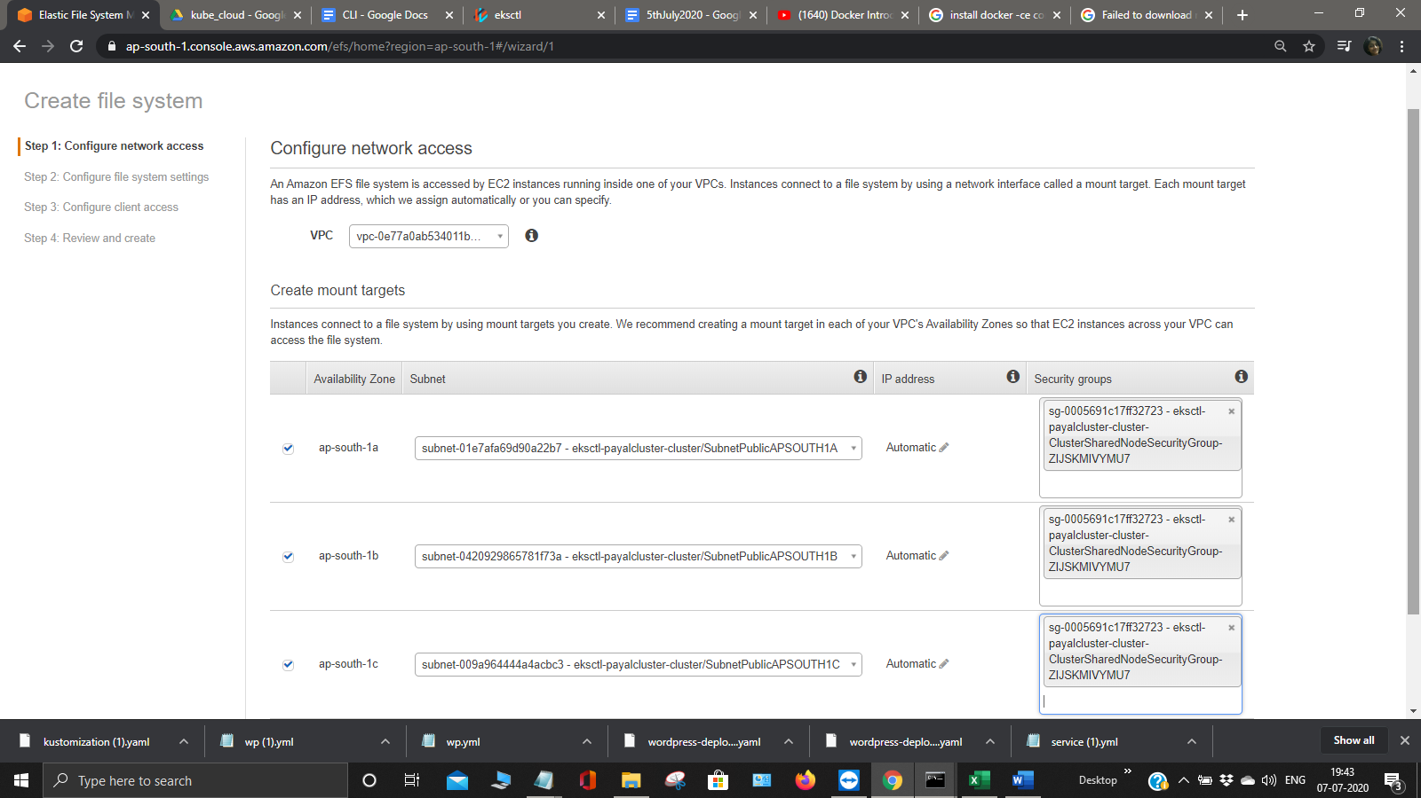

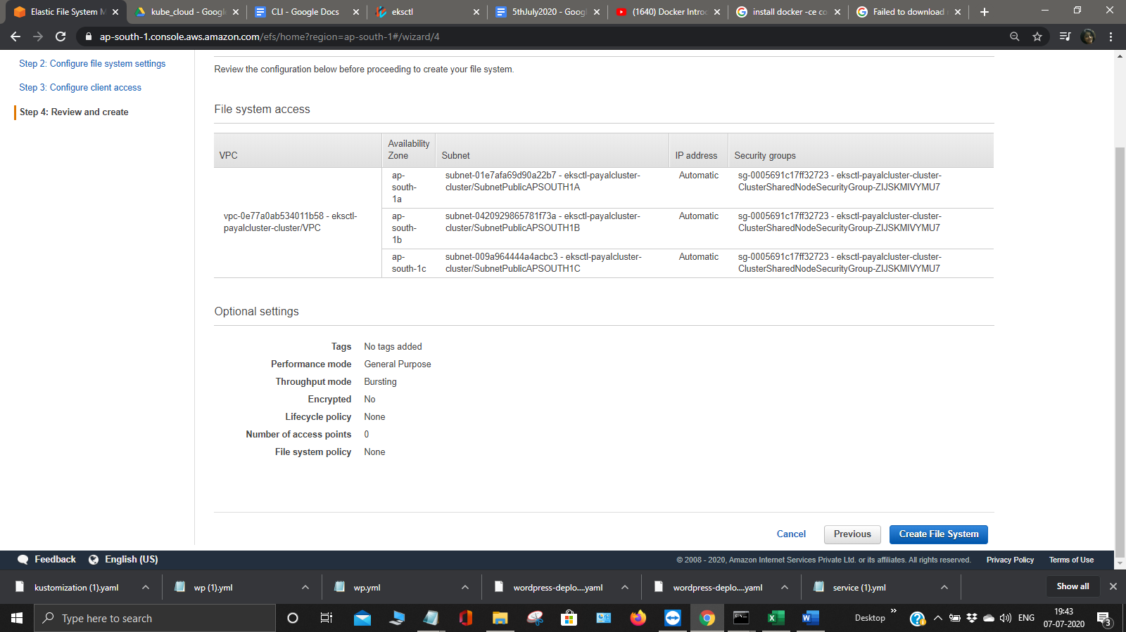

This will successfully creates EFS

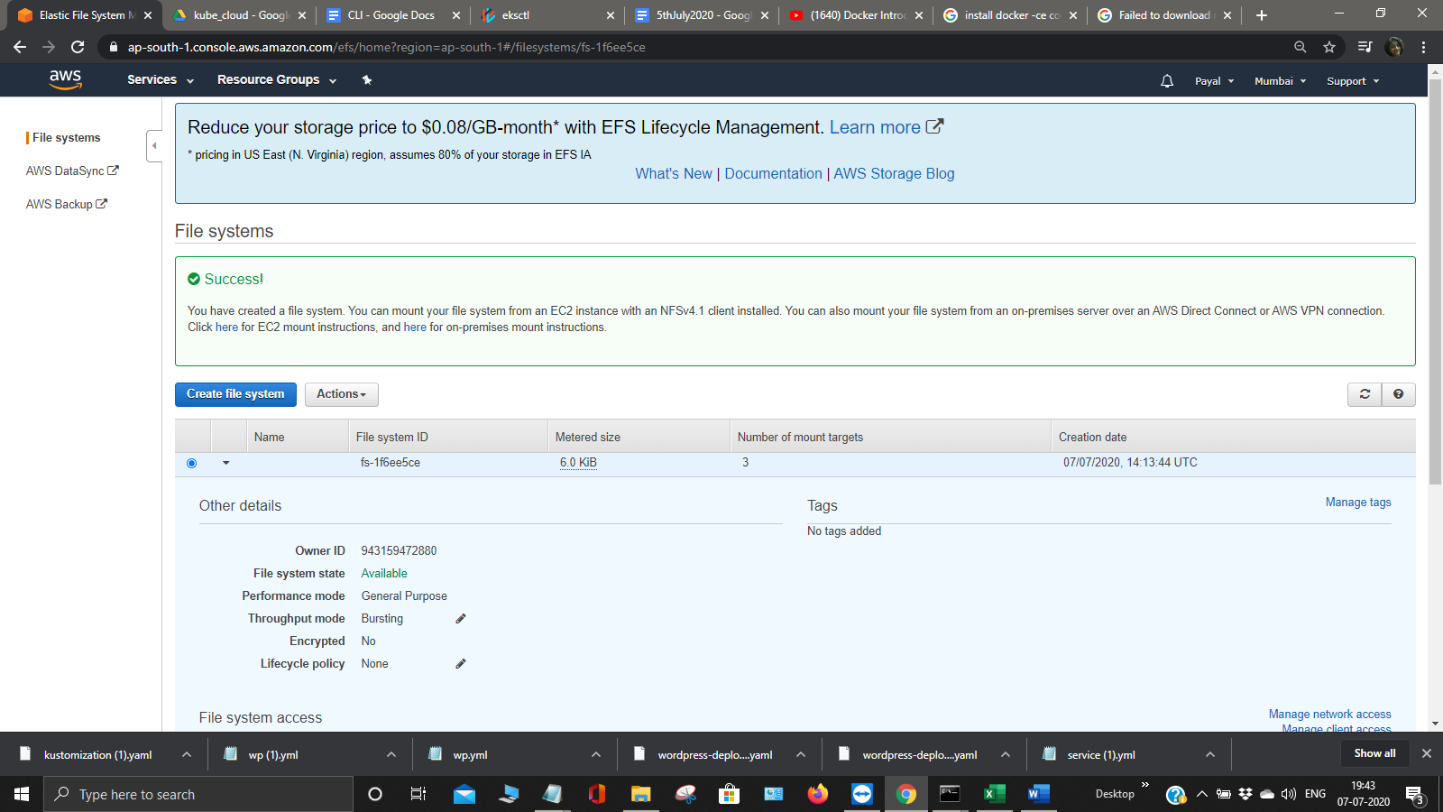

Now we will use HELM for installing the packages for installing the HELM using command helm init and set repo for that and update that.

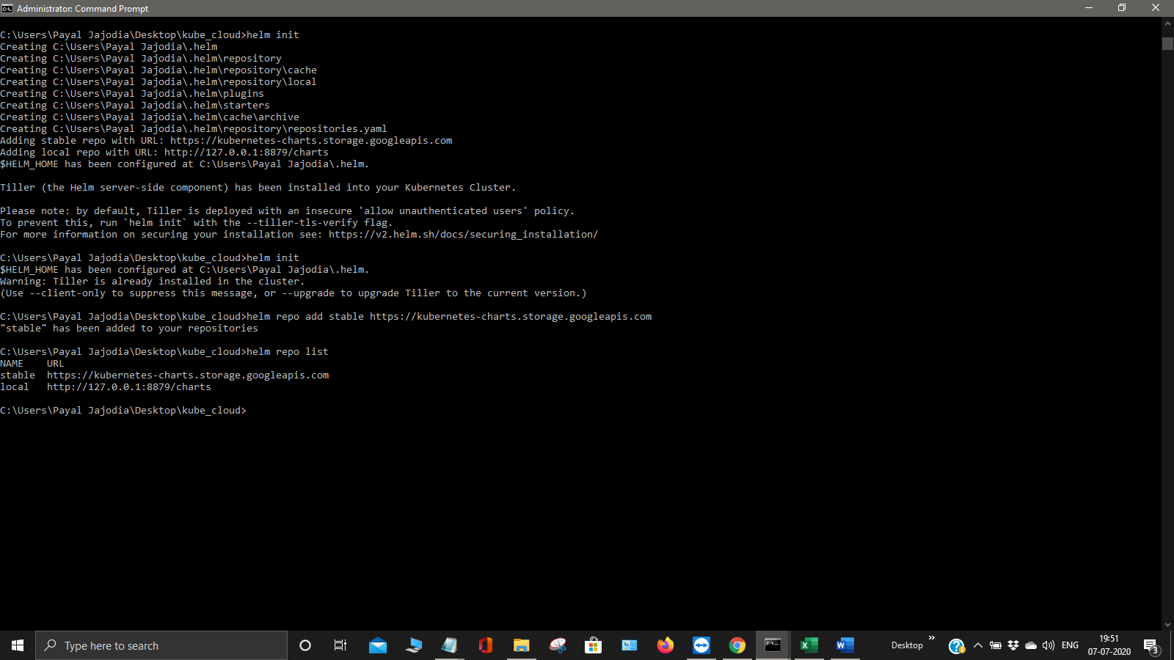

Now we will install triller it is a server side component of helm

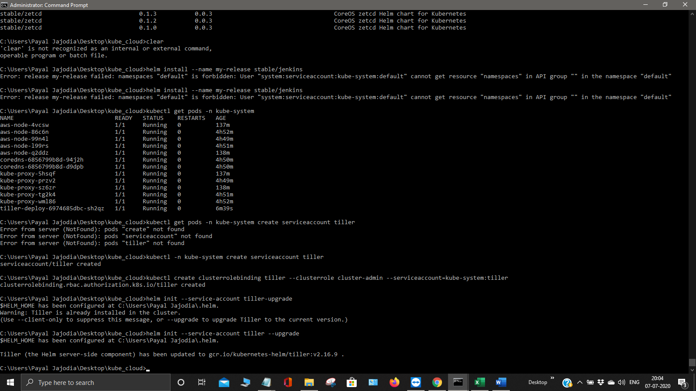

Installing Prometheus and Grafana

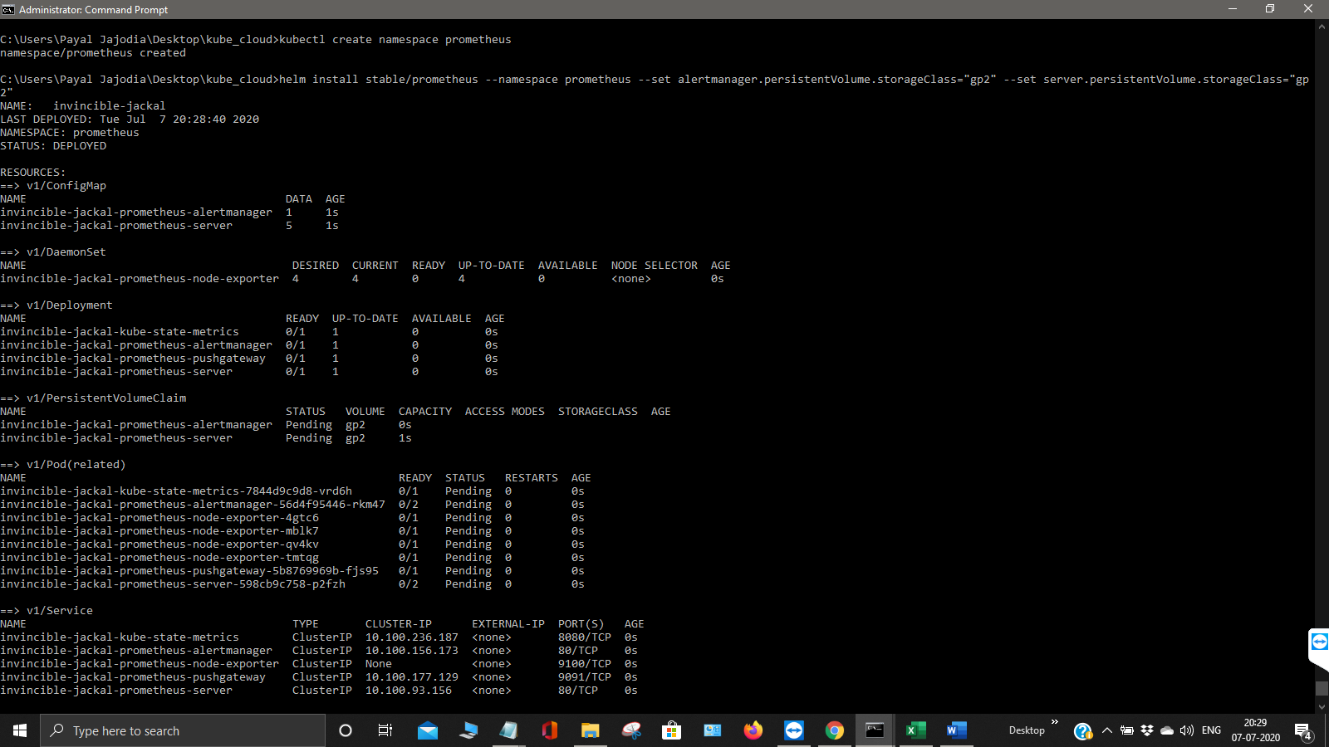

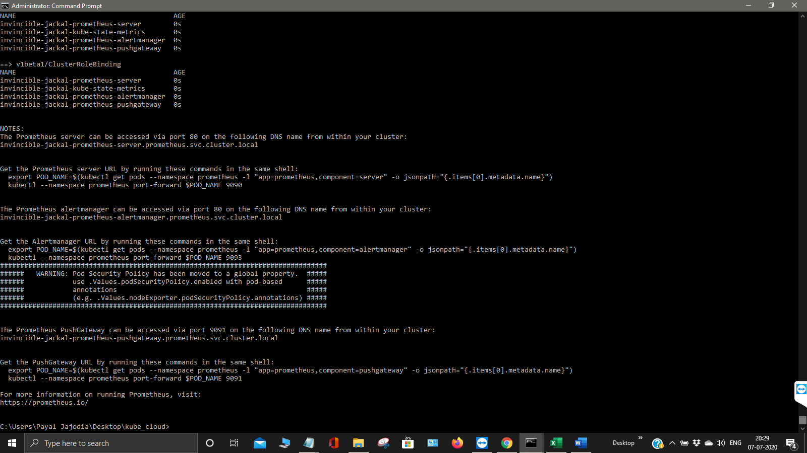

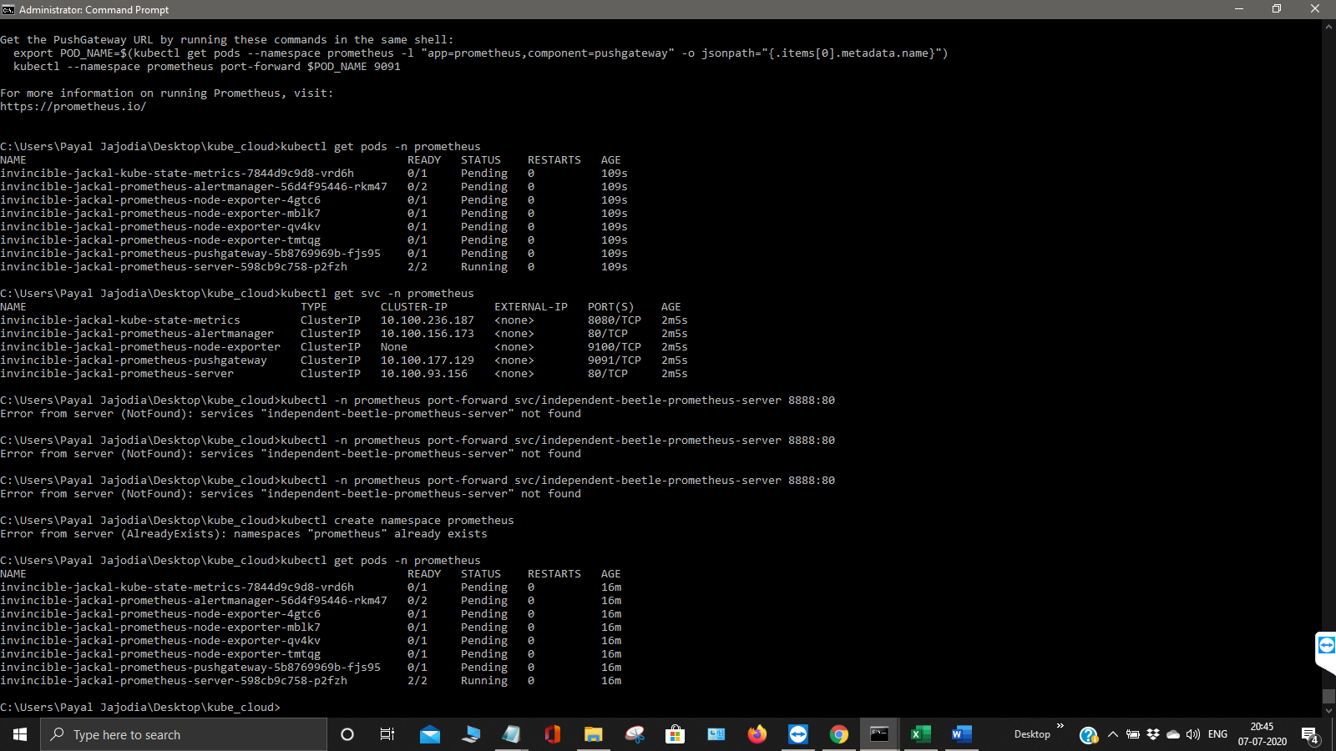

This is the complete installation of Prometheus

Now any one can use 127.0.0.1 at port 8888 and below screen will be pop up.

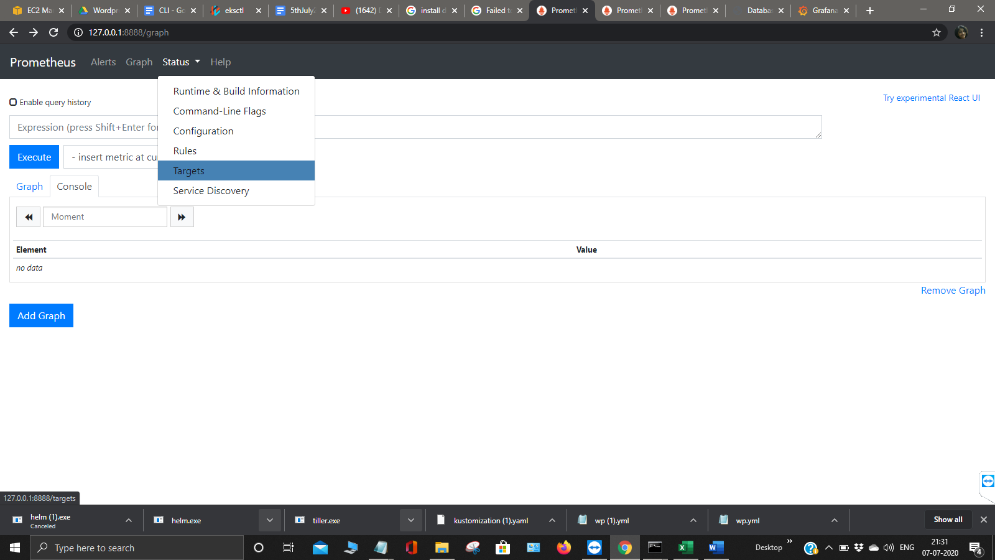

Now install Grafana

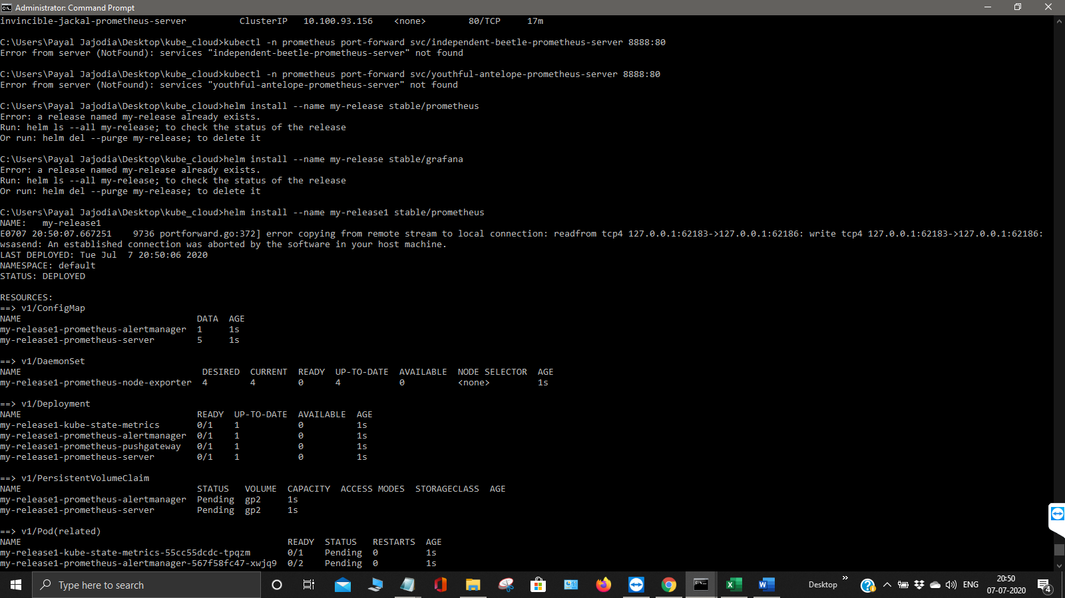

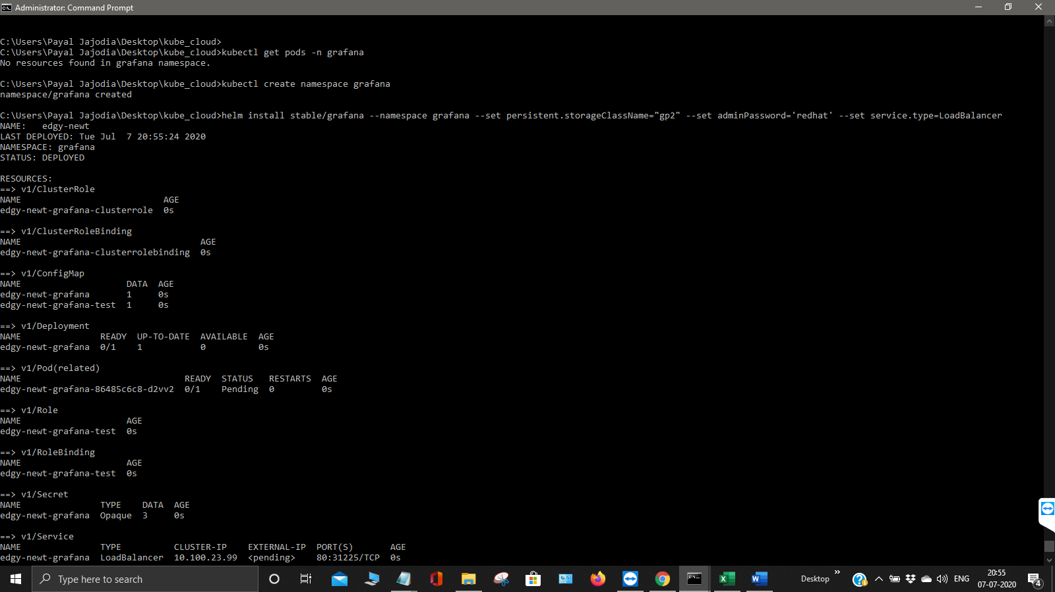

Now this will install grafan



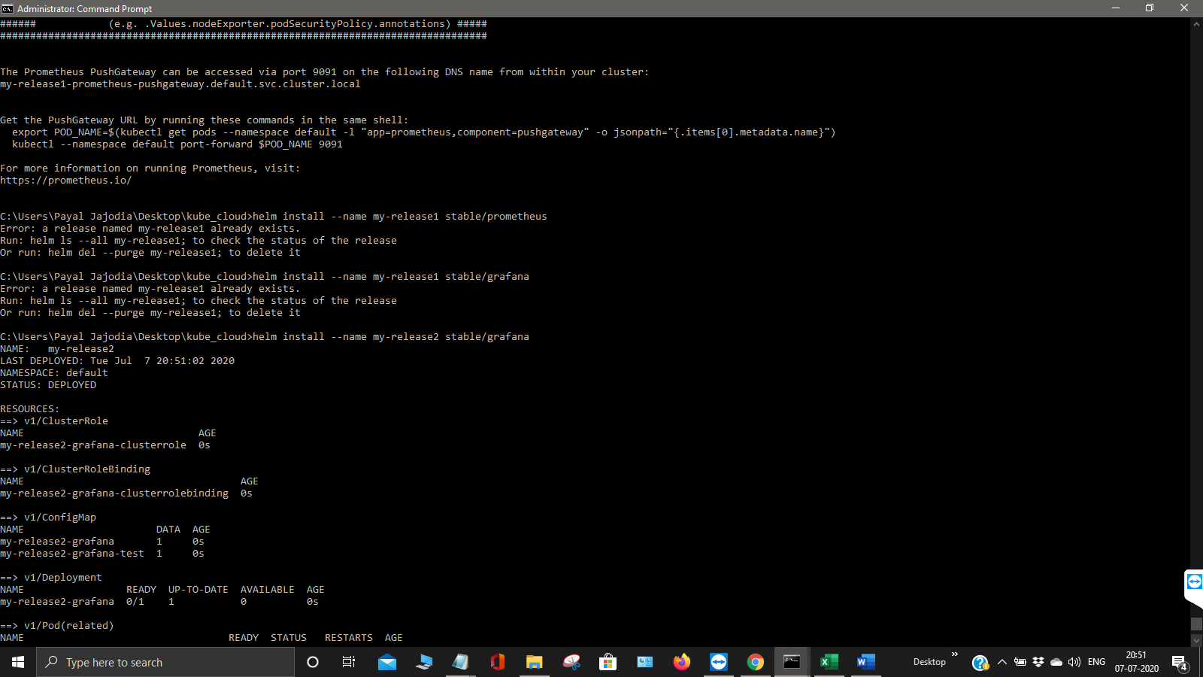

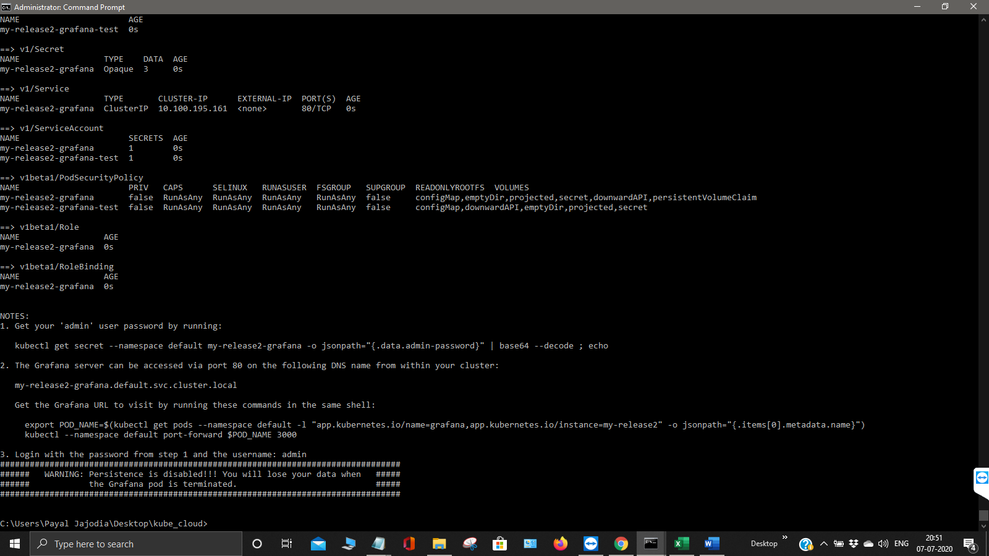

Login to your Grafan

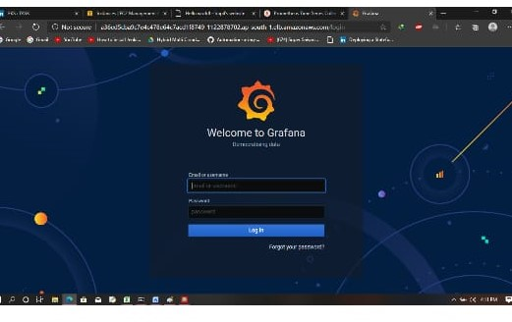

Now we will create a Fargate Cluster

AWS Fargate is a serverless compute engine for containers that works with both Amazon ECS and Amazon EKS. Fargate makes it easy for you to focus on building your applications.

Use command create cluster -f clusterf.yml

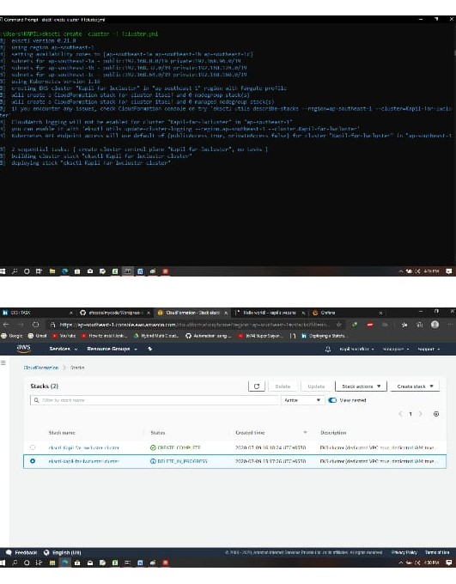

This is the final screenshot of the fargate.

